**RAJASTHAN INSTITUTE OF ENGINEERING AND**

**TECHNOLOGY**

**(2018-2022)**

**Report on Block-Chain**



DEPARTMENT OF COMPUTER SCIENCE AND

ENGINEERING

Submitted To Submitted By

Mr. Dinesh Swami Himanshu Singh

(Asst. Professor 18ERECS025

Dept. of C.S.E) BATCH A2

Abstract

Cars were in the last century the main point of the industrial revolution. Despite many markets has faced great renovation, the automotive sector looks quite the same. Moreover, from a financial perspective, data draw a picture of a low attractive and lucrative market to place investments compared to other industries. New digital technologies and industry 4.0 topic offers a great opportunity to reshape the business landscape. Ever since the launch of the Bitcoin currency in 2009, Blockchain has been a topic of great interest in technology discussions. Despite several private projects and start-ups that are blossoming in the market, there is still large uncertainty on implementations and benefits for industries. Furthermore, the academic literature is still scarce, and totally lack in automotive application. The aim of this dissertation is to explore possible Blockchain application in the automotive market. Supply chain and logistics, in particular, are considered as fertile ground due to the several parties involved and the lack of trust that usually characterize the industry. Supported by GUEST analysis is developed a business model of a Software service (SaaS) blockchain-based to manage the automotive spare parts. We considered all the main actors involved in the process to offer them an useful tool to solve their business problems with the blockchain.

# Contents

1. Introduction 2
   1. Background and Motivation . . . . . . . . . . . . . . . . . . . . . . . . . . 3
   2. Automotive market . . . . . . . . . . . . . . . . . . . . . . . . . . . . . . . 3
   3. 1.2.1 Future Trends . . . . . . . . . . . . . . . . . . . . . . . . . . . . . . 4
2. Blockchain 7
   1. Technology . . . . . . . . . . . . . . . . . . . . . . . . . . . . . . . . . . . 7
      1. Consensus Algorithms . . . . . . . . . . . . . . . . . . . . . . . . . 8
      2. Applications . . . . . . . . . . . . . . . . . . . . . . . . . . . . . . . 9
   2. Types of Blockchain and scalability . . . . . . . . . . . . . . . . . . . . . . 10
   3. Attributes . . . . . . . . . . . . . . . . . . . . . . . . . . . . . . . . . . . . 13
   4. Sorting . . . . . . . . . . . . . . . . . . . . . . . . . . . . . . . . . . . . . . 15
   5. Technology strategic analysis . . . . . . . . . . . . . . . . . . . . . . . . . 18
   6. 2.6 Blockchain in manufacturing - use cases . . . . . . . . . . . . . . . . . . . 20
3. Methodology - GUEST 21
   1. Social Business Network (SBN) . . . . . . . . . . . . . . . . . . . . . . . . 21
   2. Value Proposition . . . . . . . . . . . . . . . . . . . . . . . . . . . . . . . . 22
   3. Value Ring . . . . . . . . . . . . . . . . . . . . . . . . . . . . . . . . . . . 24
   4. Business Model Canvas . . . . . . . . . . . . . . . . . . . . . . . . . . . . . 25

3.5 Solution Canvas (SC) . . . . . . . . . . . . . . . . . . . . . . . . . . . . . . 28

1. Blockchain-based automotive supply chain analysis (AS-IS) 30
   1. Hypotesis . . . . . . . . . . . . . . . . . . . . . . . . . . . . . . . . . . . . 30
   2. Limitation . . . . . . . . . . . . . . . . . . . . . . . . . . . . . . . . . . . . 30
   3. Market/Technology analysis . . . . . . . . . . . . . . . . . . . . . . . . . . 31
      1. Blockchain in Supply chain . . . . . . . . . . . . . . . . . . . . . . 31
      2. Automotive supply chain . . . . . . . . . . . . . . . . . . . . . . . 31
      3. Counterfeited product . . . . . . . . . . . . . . . . . . . . . . . . . 33
      4. Traceability issue . . . . . . . . . . . . . . . . . . . . . . . . . . . . 34
   4. Social Business Network SBN . . . . . . . . . . . . . . . . . . . . . . . . . 34
   5. Value Proposition . . . . . . . . . . . . . . . . . . . . . . . . . . . . . . . . 36
      1. Suppliers/OEMs . . . . . . . . . . . . . . . . . . . . . . . . . . . . 36
      2. Car manufacturer . . . . . . . . . . . . . . . . . . . . . . . . . . . . 38
      3. Logistic . . . . . . . . . . . . . . . . . . . . . . . . . . . . . . . . . 39
      4. Retailer/Garage . . . . . . . . . . . . . . . . . . . . . . . . . . . . 40
      5. Car owner . . . . . . . . . . . . . . . . . . . . . . . . . . . . . . . . 42
      6. Regualators/Sevices . . . . . . . . . . . . . . . . . . . . . . . . . . 43
   6. Value Ring . . . . . . . . . . . . . . . . . . . . . . . . . . . . . . . . . . . 45
   7. 4.7 Business Model Canvas (BMC) . . . . . . . . . . . . . . . . . . . . . . . . 46
2. Solution (TO-BE) 48
   1. Solution canvas . . . . . . . . . . . . . . . . . . . . . . . . . . . . . . . . . 50
   2. Solution external analysis . . . . . . . . . . . . . . . . . . . . . . . . . . . 51
   3. Costs . . . . . . . . . . . . . . . . . . . . . . . . . . . . . . . . . . . . . . . 52
   4. Revenue . . . . . . . . . . . . . . . . . . . . . . . . . . . . . . . . . . . . . 55

5.5 Scenario evaluation . . . . . . . . . . . . . . . . . . . . . . . . . . . . . . . 58

1. Technical Framework 60
   1. Overview . . . . . . . . . . . . . . . . . . . . . . . . . . . . . . . . . . . . 60
   2. Digital twin . . . . . . . . . . . . . . . . . . . . . . . . . . . . . . . . . . . 62
      1. RFID . . . . . . . . . . . . . . . . . . . . . . . . . . . . . . . . . . 62

6.3 Framework . . . . . . . . . . . . . . . . . . . . . . . . . . . . . . . . . . . 65

1. Conclusion 68

Bibliography 70

Chapter 1

# Introduction

The aim of this dissertation is to explore possible application of blockchain technology in automotive market. Our analysis will be supported by an holistic approach in a first stage looking into all the main topic involved.

In section 1.2 we examine the car market and its predictions for the future, current trend and new challenge to address. We follow up, in chapter 2, with a description of Blockchain technology, its technical structure, the fundamental building block as the consensus algorithm and the different kind of developed framework in section 2.2. We try to examine methodologically its attributes in section 2.3 and then sort them with automotive trends in section 2.4 to come out with 3 different possible business application.

The chapter ends with an overview of Blockchain use cases in manufacturing in section

2.6.

At this stage, based on previous analysis, we focus on automotive supply chain and in the spare parts use case. An useful tool will be provided by GUEST methodology, described in section 3, which will worked-out in chapter 4. We start with an overview of automotive spare parts market, underling issues and quantitative factors in section 4.3 and collecting informations for succeeding sections. A fundamental phase will be the value proposition analysis in section 4.5 in which based on different surveys we outline business actors needs.

This is the base for the description of a service business model developed in chapter 5. Results will be sketched out in a solution canvas in section 5.1 and benefit and costs will be summarised in section 5.3 and 5.4 respectively.

At the end, a technical framework for blockchain-based supply chain quality management is proposed in chapter 6, describing the adopted technology for part tagging in section 6.2. Final considerations and future challenges are presented in chapter 7.

## 1.1 Background and Motivation

From its theorisation in 2009, Blockchain has already revolutionised the currency market, and according to many analyst is going to reshape the business landscape. Its innovative concept of trust and value are the main points of this revolution, permitting new ways of doing business. One market which as not faced the digitalisation yet is the automotive even if there are great prospect for the future of personal mobility.

Trying to figure out the development of the blockchain in the academic literature, we use the IEEE Explore digital library [87]. We queried the database with different combinations of the words: "Blockchain", "Automotive", "Car", "Vehicle" and "Crypto" and the boolean operators "AND", "OR".

The queary "Blockchain" gave 905 results and its combination with "Crypto-" was quite half of the result 436. For this reason we are not going to explore the topic related innovative currencies, in fact the combination between "Blockchain" AND "Crypto-"" AND ("Car" OR "Vehicle") gives 22 results, manly about car insurance methods. Also the query "Blockchain" AND ("Car" OR "Vehicle") with 56 results is not interesting, as 18 of them are about data privacy, and other hot topics are related to security and vehicular network. What comes out is that the academic research is focused on customer applications, neglecting the huge possible impact that could have in the B2B network.

What is really interesting, is that the combination of "blockchain" and a wide topic as "supply chain" gives 56 result, and none of them are in the automotive sector. This is an important insight for our research and will probably direct our aim to find useful blockchain application in automotive market. Moreover the combination of the word "Blockchain" and topics like "counterfeit-" "Grey market" and "lifecycle" gives below ten results.

What appears quite clear is that the automotive market players has not addressed this technology yet, and the main research in the field are related to data privacy and cryptocurrency. From our side we see great possibility to enhance business networks relations, not only from a customer perspective but also from a B2B perspective. Moreover the upcoming trend of industry 4.0 have to address a lot of challenge related data privacy and collaborative product development.

## 1.2 Automotive market

Automotive and in particular cars were in the last century the main point of the industrial revolution. The concept of personal mobility has spread all over the world, shaping the way billions of people live and deeply influencing ecosystems where cars were developed. In Europe alone, the automotive industry accounts for roughly 12 million jobs [1]; in the US, more than 8 million[2]; and in Japan, more than 5 million.[3]

Even if the market performances are strong, on a closer observation the global auto industry is more challenged than many people realise. Worldwide sales reached a record 88 million autos in 2016, up 4.8% from 2015, and profit margins for suppliers and auto makers (also known as original equipment manufacturers, or OEMs) are at a 10 year high

[4].

Nonetheless, viewed through the lens of two critical performance indicators like total shareholder return (TSR) and return on invested capital, the industry is in serious trouble. Over the last 5 years the annual rate of return achieved on average by the investors in SeP500 and Dow Jones were around 14.8% and 10.1% respectively. In the same period the auto makers TSR was only 5.5%. Moreover in 2016 the top 10 OEMs achieved a Return of investment (ROI) below their cost of capital.[4]

These data draw a picture of a low attractive and lucrative market to place investments compared to other industries. With this scenario, clearly there will be few winners in the auto industry in the next five year and beyond, but new trends and digital transformation offers a great opportunity and challenge. Today’s economies are dramatically changing, triggered by development in emerging markets, the accelerated rise of new technologies, sustainability policies, and changing consumer preferences around ownership. Digitisation and new business models have revolutionised many industries, and automotive will be no exception. Clearly companies that want to have a successful long-term future need to get key strategic decisions right in the next decade.

### 1.2.1 Future Trends

In developing this section, we took as main guideline 4 strategic consulting companies’ considerations (Mckinsey / Accenture / PWC / Deloitte)

New Markets and segmentation We have already outlined the market performances. Globally, the automotive industry has recovered from the economic crisis and the forecasts for future growth are even better. By 2020, global profits of main OEM could increase to EUR 79 billion [5]. This should be a good news, however the benefits will not be distributed equally across all geography and cars type. For sure some segment will perform better than others. OEMs need to adapt to changing regional and segment patterns of supply and demand with respect to their production and product portfolios. This factor could bring to a “portfolio mismatch” [5] as smaller vehicle classes are growing more strongly than others, particularly in fast-growing emerging markets. Population levels are increased most significantly in low-income cities, while higher income cities remain relatively stable.[6] It’s clear as urban areas will replace country or region as the most relevant segmentation dimension that determines mobility behaviour and, thus, the speed and scope of the automotive revolution. Another good opportunity will be offered by emerging markets like China. Despite its recent volatility, we expect the Chinese auto market to remain the global industry’s primary growth engine, with an estimation of EUR 30.1 billion for 2022 with a growth rate of 7.4% equal to the 52.6% of the growth in the global car market (2016 – 2022) [7]. Moreover the Chinese after-sales market, which will grow an estimated 20% per year offers a great opportunity to the congested European market [5].

New behaviour Consumer preferences, tightening regulation, and technological breakthroughs drive the shift in individual mobility behaviour. Consumers today use their cars as “all-purpose” [6] vehicles, no matter if alone or in group. The growth of sharing economies and IoT opportunities will help the development of a new ownership concept for cars. As stated in the previous section, the focus in next years will be in big cities. An examples, to make this clear, could be London or Shanghai, here congestion, lack of parking, traffic, etc. mean that car ownership could be fluid, and shared mobility represent a competitive value proposition. Such cities will provide sufficient scale for new mobility business models. By contrast, in rural areas, where low density creates a barrier to scale, private car usage will remain the preferred means of transport [6]. We will see later as blockchain could boost definitely the car sharing trend opening to new concepts of ownership.

New technologies This is probably the most managing aspect. The car industry has always been one of the most innovating sectors and is likely to be even more so in the future. All the trends and market modification discussed have to be supported by the development of new technologies. Three areas of technology are particularly important:

electronics and ICT, new composite materials and new non-fossil fuel forms of propulsion. Currently we are in the fluid phase of many new disruptive technologies like connected cars, electric vehicles and autonomous driving cars, and by now there is no mean of what will be the dominant design. However, the extent of diffusion over the next 15 years will depend on overcoming a wide range of barriers. One of them is, with no doubt, regulators and consumer acceptance that represent additional hurdles for new technologies. The future scenario is not clear as once these challenges are addressed, autonomous vehicles present a tremendous value offering for consumers , but high doubts by regulators.[6] On the opposite side we have EVs, which still perform worse than petrol based ones, but are supported by many municipalities.

Different considerations are about connected cars. Based on Mckinsey analysis, this technology will diffuse very fast. The number of networked cars will rise 30% a year for the next several years; by 2020, one in five cars will be connected to the Internet [5]. This bring great profit opportunities for car maker which can deliver services through the car like Internet radio, smartphone capabilities, information/entertainment services, driverassistance apps, tourism information, and more. Accordingly to main strategic report on automotive industry this is a promising area for future profits and differentiation.[6] [4]. Given that car owners spend about 50 minutes a day [6] in their vehicles, there is a real opportunity to monetise digital media revenues and generate additional revenue. To deliver this, OEMs will need to build relationships with affiliated firms that build apps tailored to the car but the competition will be intense, particularly if new players from digital world will enter the market and this brings us to the next point of our analysis.

New market structure The many possible future scenarios outline a shared trend, the automotive industry will face a complex and diversified landscape.[6] While markets such mobile phones have recently experienced a significant disruption, the automotive industry has not seen fundamental change in recent decades. For example, over the last 15 years, only 2 new players have appeared on the list of the top 15 automotive OEMs, compared to 10 new players in the handset industry [8].

Incumbent players will be forced to simultaneously compete on multiple fronts. The increase in regulations with respect environmental issues and safety standards will stress OEM to develop powertrains technologies for low emissions with no clue of what will be the dominant design. Moreover a paradigm shift to mobility as a service, along with the threat of new entrants, will inevitably force traditional car manufacturers to acquire new expensive competences. Many more new players are likely to enter the market especially start-ups and cash-rich high-tech companies like as Mobility providers (e.g., Uber, Zipcar), tech giants (e.g., Apple, Google), and emerging OEMs (e.g., BYD, Tesla)[6]. These new entrants from outside the industry are also show more influence with consumers and regulators (i.e., generating interest around new mobility forms and lobbying for favourable regulation of new technologies). Similarly, some Chinese car manufacturers, with impressive sales growth recently, might play an important role globally by leveraging the ongoing disruptions.[6]

With the industry evolving from competition among individual players towards new competitive interactions, but also partnerships and open, scalable ecosystems, OEMs, suppliers, and service providers need to form partnerships across and beyond the industry.

OEMs in particular need to balance global scale complexity and local specific customer demand to offer a product that meet cost efficiency but satisfy the continuously search for differentiation. This would require more sophisticated research on customer preferences.

[5]

New distribution Upward of 15% of a car’s cost typically goes to distribution [4]. There are of course variation by country or segment, but is evident that OEMs in U.S. and Europe are locket into dealer relationship which are inefficient and expensive. They should begin to explore for approaches that will reduce their costs by using more efficient channels to reach car buyers. These changes in the distribution system should ultimately aim to cut costs by minimising the number and expense of retail outlets and using technology for better inventory control [4]. Savings could come from selling via Web channels. In the U.S., for example OEMs passing through dealerships is the rule, a dictate that electric carmaker Tesla is campaigning to eliminate [4].

Chapter 2

# Blockchain

We follow up with a technology analysis, in order to understand its adaptability to the future automotive market needs. We will introduce its functionalities, attributes and different structure. At the end of the chapter supported by the literature and the analysis made we will propose blockchain application shaped according to automotive future trends.

The term blockchain is still under social construction although the core concepts of the technology seems to be agreed upon. This thesis will try to be as explicit as possible about the parts of the blockchain technology that are already well defined in bibliography and, in the same spirit, be as clear as possible about the parts that remain objects of discussion. It’s important to note that at the time of writing the literature and the aware about blockchain is constantly growing, and the contribution by the open source community spot continually new possible features. We will include important technology development during the dissertation.

One of the thing that generates the least amount of contradictory answers, is the origin of the blockchain technology. It was introduced in 2008 with a white paper about the virtual currency Bitcoin by the author behind the pseudonym Satoshi Nakamoto [9]. The paper explains the fundamental concept behind the Bitcoin which is the blockchain technology. It is actually a first clear definition of blockchain as a first step to figure out how this technology could fit other applications.

## 2.1 Technology

The blockchain is a decentralised and encrypted digital ledger, nothing more than a data structure. The ledger file is not stored in a central entity server, like a bank, or in a single data center. It is distributed across the world via a network of private computers that are both storing data and executing computations[47]; obviously, as we will see, the blockchain can run in a centralised cloud server to meet scalability and cost efficiency. Each of these computers, or virtual machines, represents a “node” of the blockchain network and has a copy of the ledger file. Every node agree on a certain set of rules, related to the allowed behaviour in the network and to the structure of the information stored. Blockchain is designed so that all stored contents are immutable. This allows all nodes to have access to the ledger as an immutable source of data. Information held on a blockchain exists as a shared and continually reconciled database [72]

### 2.1.1 Consensus Algorithms

Consensus in the network refers to the process of achieving agreement among the network participants as to the correct state of data on the system. Consensus leads to all nodes sharing the exact same data. A consensus algorithm, hence, does two things: it ensures that the data on the ledger is the same for all the nodes in the network, and, in turn, prevents malicious actors from manipulating the data. The consensus algorithm varies with different blockchain implementations.

While the Bitcoin blockchain uses Proof of Work, other blockchains and distributed ledgers are deploying a variety of consensus algorithms, like the Proof of Stake, Proof of Burn, Proof of Capacity, Proof of Elapsed Time, and many others, depending on their unique requirements. It’s very important to define them as they are the primary trait that define different blockchain and their scalability. The technology development to overcome scalability issue will focus on this algorithm.

Next, we briefly describe some of these algorithms:

Proof of Work (PoW) The Proof of Work consensus algorithm involves solving a computational challenging puzzle in order to create new blocks in the Bitcoin blockchain. Colloquially, the process is known as ’mining’, and the nodes in the network that engage in mining are known as ’miners’ [85]. The incentive for mining transactions lies in economic payoffs, where competing miners are rewarded with a small transaction fee. Multiple criticisms exist for the PoW consensus algorithm. PoW requires a huge amount of energy to be expended, given the computationally heavy algorithm. In addition, PoW has a high latency of transaction validation, and the concentration of mining power is located in countries where electricity is cheap. In terms of the network security, PoW is susceptible to the ’51 percent attack’, which refers to an attack on a blockchain by a group of miners controlling more than 50 percent of the network’s computing power [85].

Proof of Stake (PoS) The Proof of Stake algorithm is a generalisation of the Proof of Work algorithm. In PoS, the nodes are known as the ’validators’ and, rather than mining the blockchain, they validate the transactions to earn a transaction fee [85]. There is no mining to be done, as all coins exist from day one. Simply put, nodes are randomly selected to validate blocks, and the probability of this random selection depends on the amount of stake held. So, if node X owns 2 coins and node Y owns 1 coin, node X is twice as likely to be called upon to validate a block of transactions. The specific implementation of PoS can vary, depending on the use case, or as a matter of software design. Instances include Proof of Deposit and Proof of Burn. The PoS algorithm saves expensive computational resources that are spent in mining under a PoW consensus regime.

Proof of Elapsed Time Developed by Intel, the Proof of Elapsed Time consensus algorithm emulates the Bitcoin-style Proof of Work. Hyperledger’s Sawtooth implementation is an example of PoET at work. Instead of competing to solve the cryptographic challenge and mine the next block, as in the Bitcoin blockchain, the PoET consensus algorithm is a hybrid of a random lottery and first-come-first-serve basis [85]. In PoET, each validator is given a random wait time. The validator with the shortest wait time for a particular transaction block is elected the leader. This "leader" gets to create the next block on the chain.

Simplified Byzantine Fault Tolerant (SBFT) The Simplified Byzantine Fault Tolerant consensus algorithm implements an adopted version of the Practical Byzantine Fault Tolerant (PBFT) algorithm, and seeks to provide significant improvements over Bitcoin’s Proof of Work consensus protocol. The basic idea involves a single validator who bundles proposed transactions and forms a new block. Note that, unlike the Bitcoin blockchain, the validator is a known party, given the permissioned nature of the ledger. Consensus is achieved as a result of a minimum number of other nodes in the network ratifying the new block. In order to be tolerant of a Byzantine fault, the number of nodes that must reach consensus is 2f+1 in a system containing 3f+1 nodes, where f is the number of faults in the system. For example, if we have 7 nodes in the system, then 5 of those nodes must agree if 2 of the nodes are acting in a faulty manner [85].

Proof of Authority (PoA) Proof-of-Authority (PoA) is a consensus algorithm which can be used for permissioned ledgers. It uses a set of ’authorities’, which are designated nodes that are allowed to create new blocks and secure the ledger [85]. Ledgers using PoA require sign-off by a majority of authorities in order for a block to be created.

### 2.1.2 Applications

Since blockchain is a new form of digital infrastructure, applications built on top of a blockchain provide a gateway to accessing information that sits on that blockchain. In other words, clients/users interact with the blockchain through applications. Starting from the simple wallets that hold bitcoins, sophisticated applications which encompass applications addressing digital identity (e.g. UPort, KYC-Chain, Netki, etc.), and complex financial transactions are being built on the blockchain [85]. In order to have a wide view we are not going to analyse a singular application on the market, but analyse the concepts of smart contracts, apps and Internet of things. Is important to note that this particular field is probably the most powerful and undefined as in continuous growth due to its open source nature.

Smart contracts and Apps

The hype around blockchain boosted the development of different standards and protocols. After the release of the white paper by S. Nakamoto another important step further was made by Vitalik Buterin, co-creator and inventor of Ethereum, described in his white paper as a “decentralised mining network and software development platform rolled into one”, that facilitates the creation of new cryptocurrencies and programs that share single Blockchain [9].

Ethereum does this by building what is essentially the ultimate abstract foundational layer: a blockchain with a built-in Turing-complete programming language, allowing anyone to write smart contracts and decentralised applications where they can create their own arbitrary rules for ownership, transaction formats and state transition functions. The concept of smart contracts was first introduced by Nick Szabo in 1994 and defined as “a computerized transaction protocol that executes the terms of a contract” [10]. In the context of Blockchain, smart contracts are autonomous agents or scripts that are stored in a Blockchain [17]. They are a tool to program and automate any type contract or agreement, written in software rather than written in legal text. Through code, contractual conditions of a transaction are defined on blockchain. Once those conditions have been met, the transaction is automatically executed through code [11].

Not only smart contracts but also decentralised application (Dapps) could be written on blockchain. Dapps are an Ethereum tool that serve some particular purpose to its users [12]. Users interact in a P2P fashion with other users, without middleman, through a variety of interfaces - social, financial, gaming, etc. Since the applications are developed on the decentralised consensus-based network itself, third-party censorship is virtually impossible. Malicious actors cannot secretly tamper with the application by changing the code and compromise all application users (or nodes that are actively interacting with it)

[85].

Instead of having to build an entirely original blockchain for each new application, companies can instead use the Ethereum (or future dominant platform) to develop and deploy applications suited to their needs. As reveals the white paper about Ethereum, “Activities that have any economic or governance aspect, conceived or as of yet unconceived, can be done via Ethereum, provided that the right code is written and the necessary hardware or other required things are used.” [13]

This concept has a particular importance in the field of logistics contracting. Smart contracts enable the automation of transactions that are not value added, creating room for enterprise blockchain based solutions. Moreover, they lead to solve the inter-parties lack-of-trust issue which characterise logistics activities. Not only smart contracts reduce the chance for human error or cases of fraud, but they also increase the privacy, the cost and time efficiency as well as the trustworthiness [14].

Internet of Things

Generally speaking, IoT refers to the networked interconnection of everyday objects, which leads to a highly distributed network of devices communicating with human beings as well as other devices [15].

Internet of Things (IoT) is experiencing exponential growth in research and industry, but it still suffers from privacy and security vulnerabilities. These issues could be solved with a scalable, trust-less, peer to peer technology able to make data communications between devices secure and transparent, and BC seems to fit well this purpose. As described by Dorri [16], three are the blockchain characteristics that make the technology a potential platform to interconnect IoT devices: decentralisation, anonymity, and security . The blockchain decentralised feature ensures scalability and robustness, typical of decentralised network. The anonymity and security ensure the device’s user privacy and security against untrusted parties, who can access sensible personal information collected by IoT devices.

In supply chain, by simply equipping the stakeholders of the container process with a smart tracker, a GSM or LTE radio to connect to the Internet, and an installed blockchain it is possible to revolutionise the entire supply chain of containers [17]. These enabling technologies allow devices to write approved transactions autonomously to the blockchain without prior user input, and to move the process forward with the use of smart contracts.

## 2.2 Types of Blockchain and scalability

Historically, Blockchain started as a public permission-less technology when it was used for powering Bitcoin. Since then, other types of blockchains have been created. These can be categorised as a combination of public/private and permissionless/permissioned. Each type fits a specific set of use cases. In general, public/permission-less blockchains are open, decentralised and slow. Private/permissioned blockchains are closed and centralised, either partially or completely and also more efficient. Main differences are summarised in the table 2.1 took from EdX [85].

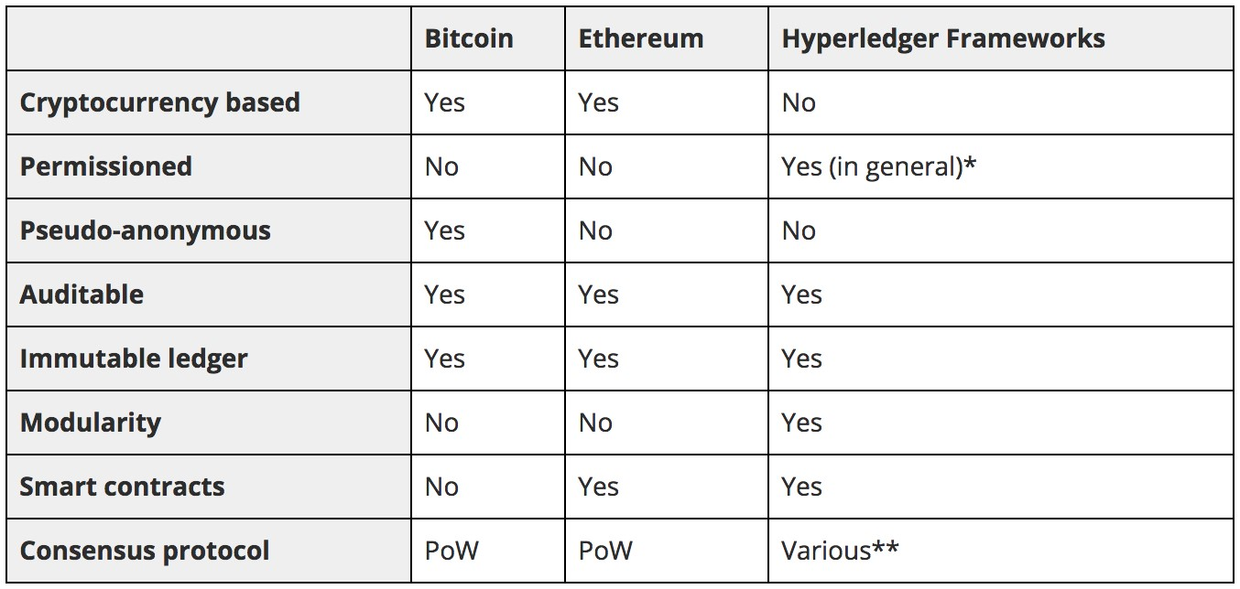

Figure 2.1. Types of Blockchain and main differences

Bitcoin

The Blockchain Technology started with the advent of an alternative crypto currency called bitcoin. Bitcoin is a currency used for an online payment system that uses encrypted techniques to generate units of currency and verify the transfer of funds while operating independent to intermediaries as a central bank or single administrator [76]. Transactions are verified by network nodes through cryptography and recorded in a public distributed ledger called blockchain. Public blockchains are, as the name indicates, blockchains that are accessible to every user on the Internet, which also means that anybody may participate and affect the blocks that are added to the chain. Until now the throughput of the blockchain is restricted to 7 transactions per second due to the restricted size of block, while VISA can handle up to 47000 transactions per second [21]. This low performance is caused by its consensus algorithm and its permission-less structure.

Ethereum

is an open-source, public, blockchain-based distributed computing platform to build and distribute the next generation of decentralised applications [13]. Applications with no middleman, where user interact with social systems, financial systems, gaming interfaces, all in peer-to-peer fashion. Ethereum provide a blockchain with a built-in and complete programming language that can be used to create smart contracts and code state process functions, allowing users to easily create any system, as well as other applications not yet imagined [13]. Ethereum takes the core blockchain technology that Bitcoin conceptualised and evolves it, making it applicable to a wide number of business. Everything Bitcoin can do, store money, sending/receiving payments, Ethereum can also do but does it more efficiently. Probably the biggest scalability issues with Ethereum are that every node has to process all transactions and has to store the entire state of every account balance, contract code and storage, etc. Although this provides a large amount of security, but greatly limits scalability to the point that a blockchain cannot process more transactions than a single node. Currently the Ethereum blockchain is limited to 15 transactions per seconds.

Hyperledger

Hyperledger is a group of open source projects focused around cross-industry distributed ledger technologies. Hosted by The Linux Foundation, collaborators include industry leaders in technology, finance, banking, supply chain management, manufacturing, and IoT [85]. Hyperledger provides an alternative to the cryptocurrency-based blockchain model, and focuses on developing blockchain frameworks and modules to support global enterprise solutions. The focus of Hyperledger is to provide a transparent and collaborative approach to blockchain development [86]. Its peculiarity is the possibility to create "channels" or private blockchain which are faster but reduce the security. They are suggested in business with trusted parties. As of April 2018, Hyperledger consists of eight projects, five of which are distributed ledger frameworks. We will present below the most important;

Hyperledger Sawtooth Hyperledger Sawtooth, contributed by Intel, is a blockchain framework that utilises a modular platform for building, deploying, and running distributed ledgers. Distributed ledger solutions built with Hyperledger Sawtooth can utilise various consensus algorithms based on the size of the network. It includes the Proof of Elapsed Time (PoET) consensus algorithm, which provides the scalability of the Bitcoin blockchain without the high energy consumption. PoET allows for a highly scalable network of validator nodes. Hyperledger Sawtooth is designed for versatility, with support for both permissioned and permissionless deployments.

Hyperledger Iroha Hyperledger Iroha is a blockchain framework contributed by Soramitsu, Hitachi, NTT Data, and Colu. Hyperledger Iroha is designed to be simple and easy to incorporate into infrastructure projects requiring distributed ledger technology. Hyperledger Iroha emphasises mobile application development with client libraries for Android and iOS, making it distinct from other Hyperledger frameworks. Inspired by Hyperledger Fabric, Hyperledger Iroha seeks to complement Hyperledger Fabric and Hyperledger Sawtooth, while providing a development environment for C++ developers to contribute to Hyperledger. In conclusion, Hyperledger Iroha features a simple construction, modern, domain-driven C++ design, along with the consensus algorithm YAC.

Hyperledger Fabric Hyperledger Fabric is an implementation of a permissioned blockchain network. A permissioned blockchain means that any node is required to maintain a member identity on the network. Even end-users must be authorised and authenticated in order to use the network [56]. This is completely different to Bitcoin and permissionless blockchain, as it’s not completely public. Participants in the network can interact in a manner that ensures that their transaction and data can be restricted to an identified subset of network participant, known as a channel. The members in the channel has the ability to establish a shared ledger containing digitised assets and recorded transaction only available to the members in that channel. There is only one ledger per channel, which is shared across the peers. Adding more peers to a channel should affect the performance on just that channel, other channels will not be affected considering how separated channels are from each others.

Hyperledger Fabric provides a modular architecture, which allows components such as consensus and membership services to be plug-and-play [85]. The Fabric architecture is composed by the following components: peer nodes, ordering nodes and client applications. These components have identities derived from the certificate authorities.

A peer can have two roles; it is called "committer" when maintaining the ledger by committing transactions, and "endorser" when it is responsible for simulating transactions by executing chaincodes and endorsing the result [56]. Peers are not limited to a single role. A peer may be an endorser for certain types of transaction and just a committer for others. The ordering nodes decides the order of transactions in a block to be committed to the ledger.

It is possible to add endorsers and committers without having to add corresponding orderers. Furthermore, endorsers may have to execute heavy computations, but since endorsers are separated from the ordering service it does not affect it’s execution time. Developers are therefore free to write more complex applications that are costly to execute without disrupting the ordering service or any other application on the network. Developers can also implement their own protocol to plug into the service as client application. The work done by peer and ordering nodes are roughly the same kind of work that miners do in the other blockchain architectures.

## 2.3 Attributes

In this section we discuss the attributes of blockchain. This is a fundamental step for a more methodogical analysis of its business implications in various industries. In our opinion this is necessary as attributes reveal what a technology has to offer and in turn how it may affect a business. We will use the book ‘The Business Blockchain’ by Mougayar

[46] as a general guide. The key attributes of blockchain are discussed below;

* Privacy;
* Trasparency;
* Security;
* Equitable access;
* Cost saving;
* Speed;
* Efficiency;
* Quality.

Privacy Nowadays the importance and impact of data is commonly known, and also its related risk. There have been growing discussion concerns business that collect and control personal data for the risk of breaches compromising user privacy. The automotive market has not move totally to the digital world yet, and blockchain could be a great opportunity to solve by design this important issue. Smart vehicles are increasingly connected to roadside infrastructure (e.g., traffic management systems), to other vehicles in close proximity, and also more generally to the Internet, thus incorporating vehicles into the Internet of Things (IoT). This high degree of connectivity makes it particularly challenging to secure smart vehicles. Malicious entities can compromise a vehicle, which not only endangers the security of the vehicle but also the safety of the passengers [16].

Due to its decentralised nature, blockchain reduces the possibility of privacy breaches. In a blockchain network, there is no central authority all the data recorded on blockchain is heavily encrypted to maintain virtual privacy [12]. Moreover data is under user’s control, which entails that people receive compensation for any use of data that has value to another party [18].

Trasparency. Blockchain leads to transparency between firms and stakeholders as data auditability becomes possible [12]. The automotive market has different stakeholder and a long supply chain, for this reason the BC could solve the transparency and trustiness risk between counterparts. It will mitigate grey parts trading with financial and performance positive outcomes. It enables the creation of secure digital product memories, immutable records of everything from the source of the raw materials used, to where and how they were manufactured, to their maintenance and recall histories. Blockchain will allow the creation of “trust factories” – decentralised institutions and organisations that provide trust at a far lower cost than traditional providers [19].

Security. It’s still a relatively new technology, so we don’t have all the answers yet, but blockchain clearly has the potential to have a big impact on data security. With a world moving strongly on data based decision making, blockchain could be an answer to avoid risk of violations and attack. Decentralised protocols are more resilient to cyber attacks as data is distributed and protected with encryptions. This aspect will be fundamental for the development of connected car [44]. However as we will see the blockchain has a constrain trade off between security and scalability.

Equitable access. Blockchain could democratise a lot of services promoting transparency and trustiness between parties. This eliminates the need of intermediaries that take a part of the transaction value. An example is Bitcoin that allow two billion of people that could be excluded, to have access to the financial and economic system. The high infrastructure costs related to banking and other financial operations make micropayment and micro accounts unfeasible to include these groups in the financial eco-system [12] ; moreover the instant data access make available and ready to use many indicators like resource availability, tracking and general indicator which will be the base for automated decision making.

Cost saving. With the current technology the reduction of business cost with the adoption of blockchain isn’t immediate, due to an immature technology and a small pool of specialist. Nevertheless experts had moderate agreement that real financial benefits from blockchain will come from cost savings made possible due to the removal of intermediaries [45]. Blockchain based transaction fees are very low as advised by the expert panel, eliminating costs associated with replicating and distributing data. Moreover positive outcomes could come from intensive data mining and from the sub-sequential process improvements. We therefore, see blockchain improving the ‘profitability’ through savings in the ‘cost structure’ of a firm [45].

Speed. The absence of intermediaries, substituted by an automated decentralised network increase transaction speed and avoid long bureaucratic procedures. The interoperability of data could boost process as there is no latency in updates. For example, international remittance service normally takes a few days to transmit funds, whereas on blockchain this can be done within minutes [45]. But also smart contracts could boost fragmented process like supply chain. The possibility to share real time trusted data as location or about availability will open to automatisation of decision making.

Efficiency. Many use cases proposed for blockchain focus on increasing efficiency by reducing time and costs. This is the natural outcomes of the reduced risk, increased transparency of transaction and data availability. Blockchain could open new unprecedented collaboration between participants resulting in process efficiency. In the case of supply chains, blockchain-based tracking of goods and materials can allow detailed tracking and prevent counterfeit products entering the chain and prevent substitution of higher quality with lower grade materials [20]. Is important to know that the efficiency provided by the BC in preventing counterfeit product will be proportional to the brand added value. An example could be apparels in which most of the value comes from the brand, or commodities in which brand is fundamental for market differentiation.

Quality Trying to summarise all the attributes, Blockchain will boost with no doubt process quality. One example could be in the Public sector. Technology could simplify the management of trusted information, making it easier for government agencies to access and use critical public-sector data while maintaining the security of this information [73]. With the same reasoning it will improve the quality of patient care. Even in the manufacturing companies, with the absence of grey parts trading, trusted suppliers will increase the quality of their products.

## 2.4 Sorting

Based on the holistic approach we tried to develop widely all the topic involved in the analysis. Supported by the bibliography we are now going to compare the findings in the market and technology summarised respectively by trends and attributes (figure 2.2). In doing this will be supported by the report of Deloitte about Blockchain application in the future car [44].

Verification and process improvements

NEW DISTRIBUTION

Blockchain may improve process efficiencies across the supply chain and back office in the automotive industry. As we already underlined, automotive supply chain account a lot in the whole value of a car. Across the value chain there are many use cases aimed at enabling verification and process improvements.

Know your supplier A blockchain based solution that captures, stores and verifies supplier details, using external information, prior to the supplier providing services to automotive organisations. This is very powerful to avoid litigation and to improve product design. Moreover this open to new innovative business transaction based on verified

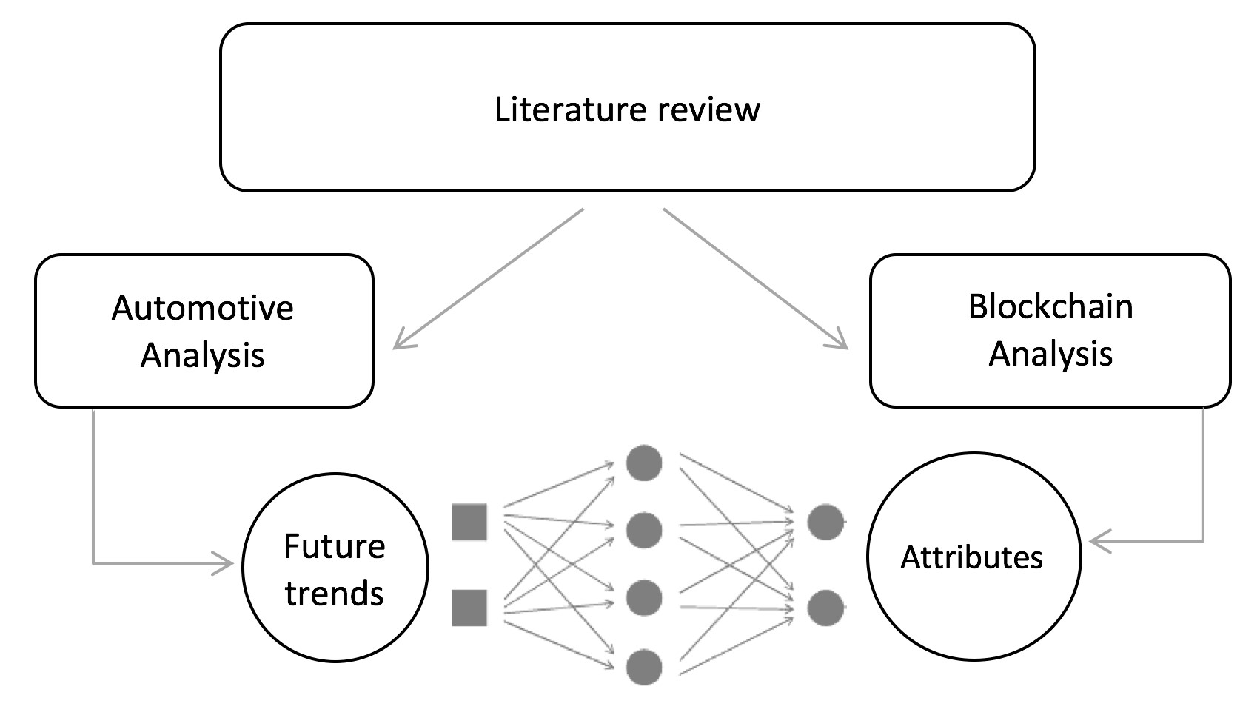

Figure 2.2. Sorting process merging attributes and trends

performance. Supplier contracts could be stored on the blockchain and payments executed when a service or product has been fulfilled. Data can also be provided ’off-chain’ to support supplier performance reporting and to inform future contractual agreements.

Provenance/ Trace and verify parts A Blockchain based solution that captures, stores and updates information on vehicle parts including spare parts. It will enable the service centre, car manufacturer and customer to trace the origin of spare parts through the supply chain limit jeopardization by counterfeited product and improve quality and safety.

Connected supply chain A blockchain based solution that provides an end-to-end supply chain solution to enable automotive organisations to seamlessly order or sell, track and pay for goods once they arrive at their destination. As we will see this is already an objective of automotive industry. Blockchain will integrate smart contracts and transaction security. Documentation would be created, updated, viewed or verified by parties on the blockchain. Payments could also be initiated seamlessly between parties throughout the process based upon agreements.

Targeted recall A blockchain based solution that enables car manufacturers to identify vehicles that contain defective parts, and therefore issue specific recalls or service bulletins for these vehicles. Moreover targeted maintenance based on data. This can reduce disruption to customers as well as the recall costs for the process. This application will also track the status of the recall, for instance vehicles received by dealer for repair or vehicles repaired, which can be used for regulatory reporting to government.

Vehicle management and incentives

NEW MARKET STRUCTURE, NEW BEHAVIOUR

Blockchain applied to physical product gives them the flexibility and business possibilities similar to a digital asset. This will open to a wide range of possible business with the no need of intermediaries or services providers following the current trend of platform business.

Dealer and customer incentives A blockchain based solution that records dealer and customer purchases and issues loyalty points that can be used as a currency within the OEMs loyalty network. Blockchain enable car manufacturer and OEMs to follow new and innovative customer relationships strategies.

Extended vehicle ledger A blockchain based solution that securely stores, updates, traces and shares vehicle data (including telematics) across OEMs and with external parties in real time. The vehicle ledger could include the car’s maintenance and ownership history and would enable OEMs and other authorised parties to view and provide additional services. This technology could complement or replace the physical log book.

Odometer fraud A blockchain based solution that through an IoT sensor send vehicle mileage data on a regular basis to its ‘digital logbook’. If odometer tampering is suspected, it could be checked easily. A car owner can log their mileage on the blockchain and when they sell their vehicle, receive a certification of accuracy that increase the value of the car.

Ride sharing and on-demand mobility services A blockchain based solution that records and executes agreements and monetary transactions to enable vehicle owners to monetise trips. This solution would interconnect smart and/or autonomous vehicles, carsharing providers and the users in a secure and reliable manner. Users and car-sharing providers will exchange data securely, like vehicle location, keys to unlock the car and agreement terms.

Finance, payments and insurance

NEW MARKET STRUCTURE, NEW BEHAVIOUR

The most famous Blockchain implementations are in financial services. Blockchain may improve transactions processes and information in automotive industry.

Insurance contract A blockchain based solution that enables insurance firms to create personalised vehicle insurance contracts based on actual driving behaviour and automate the payment. Driving behaviour and safety events like collisions, could be stored on the blockchain, shared and used to calculate insurance premiums and payments. The record will be linked to the driver to facilitate the data sharing between insurance companies.

Auto leasing and finance A blockchain based solution that connects the involved entities when leasing a vehicle to a customer in a secure way, from performing credit check prior to leasing the vehicle, storage of leasing agreement/contract on the blockchain, through to automated payment once the vehicle has been returned.

connected services A blockchain based solution that enables vehicle owners to purchase ’infotainment’ services or additional customer services. Like for example service linked to car parking, from automatic payment to temporary rent of private car parking.

Electric vehicle payment A blockchain based solution that manages contracts, billing and payments when an electric vehicle owner charges their vehicle at a charging station owned by a third party.

## 2.5 Technology strategic analysis

SWOT Analysis

This nascent technology has immense opportunities to revolutionise supply chain as well as threats to examine and confront before actual implementation. Blockchain create visibility to show where things are as well as traceability to track where things have been. It will reduce or eliminate fraud, errors, waste, cost, and delay and increase efficiency and interoperability in the supply chain. However, it is not a mature technology so that there are some potential barriers from technology, governance, organisation and even society. Lack of awareness and understanding of impact on supply chain will make blockchain not easy to adopt. Besides, the high investment for implementation and human resource would be intimidating. Last but not least, it is challenging to establish and maintain properly system for security and privacy of data in a complex business world.

Table 2.1. SWOT internal analysis of Blockchain technology

|  |  |
| --- | --- |
| Strengths | Weaknesses |
| * Immutability and transparency * shared database through P2P network * Cryptography ensure security * Distributed resilience and control * Process integrity * Faster transaction * High quality data * Durability, reliability and longevity | * Slower performance compared to traditional database * Absence of strong sales/marketing expertise * Slow settlement * Network speed * Nascent technology * Lack of standards * Immature scalability |

Technologies of general applicability.

The outcomes from investing in Blockchain is not limited in the field of application. Its a modern trend in many technology-based firms to engaged in business-model innovation by pursuing strategies in which they invest in technologies with more general applicability. New kinds of business problems, raised by these trends, are arising from the distance between general-purpose scientific technologies and the techniques required for understanding how to put them into use effectively. Typically, the development of technology especially general purpose technology requires skills, assets and investments in engineering

Table 2.2. SWOT external analysis of Blockchain technology

|  |  |
| --- | --- |
| Opportunities | Threats |
| * Improve transparency * Enhance traceability (track parts and service provenance) * Reduce or eliminate fraud errors, waste, cost and delay * Enrich relationship across supply chain * Built trust and reduce conflict between partners * Prevent counterfeit end ensure authenticity * Mind the data gap and open forecasting (decision synchronised) * Increase efficiency and interoperability | * Awareness and understanding * Motivation and involvement * Immaturity of technology * Lack of developers and experts * Cultural adoption * Integration concerns * Control, security and privacy * High investments in implementation * Time-consuming negotiations to reach consensus * Uncertainty about impact * Saturated race market |

and scientific disciplines and knowledge in research. Understanding which product or service might become commercially successful requires sociological and marketing insights, experimentation with users, and the ability to match needs with technological solutions. Thus the capabilities required to be effective in commercialisation differ quite significantly from those required to develop new science[40]. As an innovating firm seeks multiple markets in which to deploy its technology, it may choose to accept relatively small profits in each market niche, but accrue returns across many market niches.

## 2.6 Blockchain in manufacturing - use cases

While the majority of research projects is still focused on the technology itself and applications in the finance industry the interest to exploit blockchain in the manufacturing industry is increasing. Especially the application of blockchain for supply chain management and auditing is investigated by several start-ups and large companies. In addition, the role of blockchain for Industry 4.0 and the Internet of Things (IoT) is discussed and some companies are combining blockchain solutions with 3D printing to enable new manufacturing processes. An overview of the use cases are introduced in figure 2.3 took from the blog medium [88].

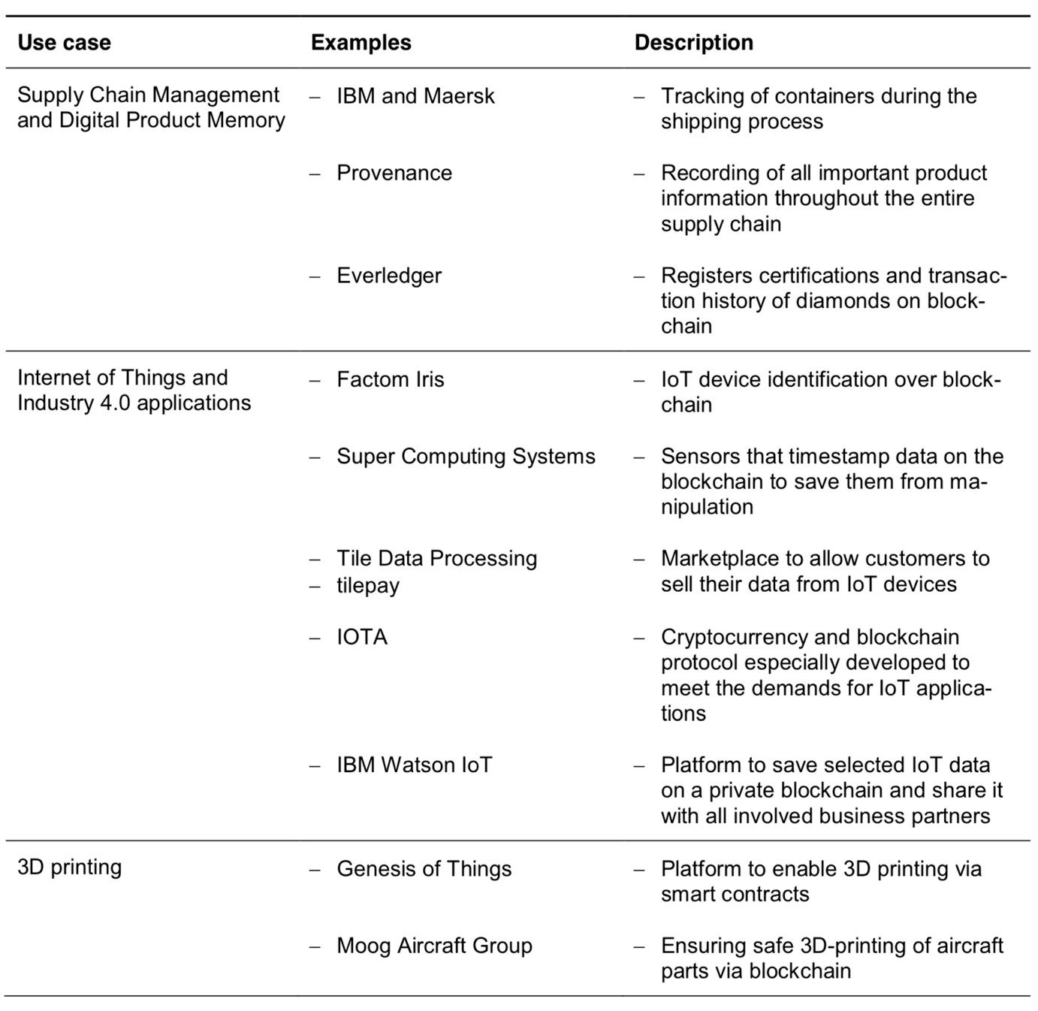

Figure 2.3. Manufacturing industries use cases

Chapter 3

# Methodology - GUEST

We now propose a derived form of methodology GUEST [35] to meet the requirements of the use case. In particular the choose to create a business from the bottom without take the role of any player force us to adapt the methodology. The internal and external analysis of the company, carried with an interview in the GUEST will be substituted by a market analysis. Followed by a Social Business Network SBN, fundamental to understand market relationships. In the Value Ring we are going to highlight in a graphical form the customers behaviour and in the Business Model Canvas we will summarise our BM solution.

## 3.1 Social Business Network ( SBN )

The Social Business Network (SBN) is a “visual document intended to represent a company in its environment in order to assess any possible positive and/or negative interaction between all elements of the system”[35]. In our case is a very useful tool to understand which are the actors and decision makers that are affected by the introduction of the new technology.

Please note that the arches can be unidirectional or bidirectional. At the base of the SBN, there are three basic premises:

* The actors and their actions are considered as interdependent units, rather than independent or autonomous units;
* The relational links between the actors are channels for the transfer or the flow of resources (both material and non);
* The network models are considered structural environments that provide opportunities or constraints for individual action.

The SBN is presented taking into account the relations in the legenda (figure 3.1). In this way, a standard representation will be immediately readable and understandable by all. The founding premise of SBN is that each actor interacts with the others and that such interaction influences and changes the behaviour of both. This scheme is crucial because in the analysis of the environment in which a business entity operates, usually are primarily considered the direct type of relationships, losing the overview. However, it is possible that, considering only the first-level interactions apparently without problems, you neglect visible relationships only considering the MACS overall.

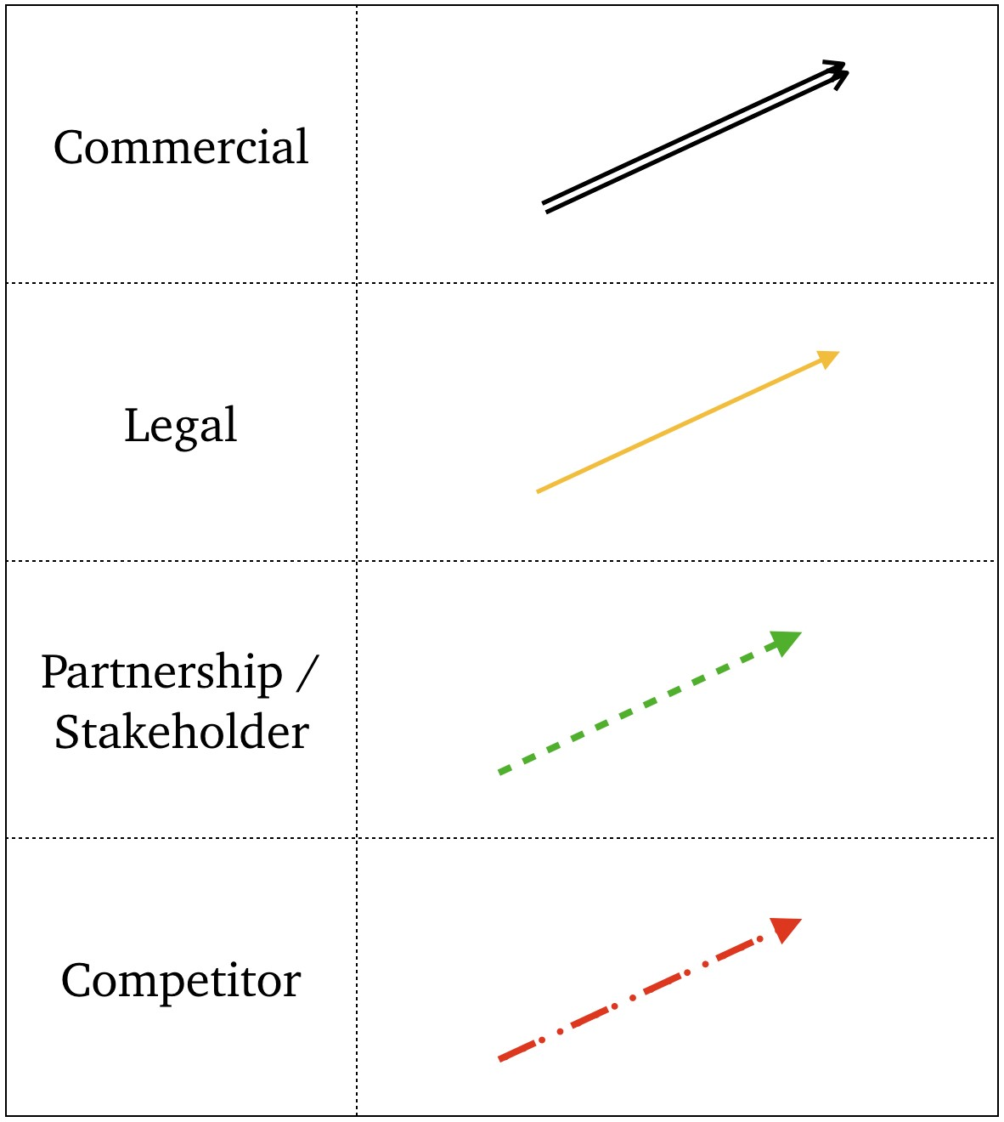

Figure 3.1. legenda

## 3.2 Value Proposition

The core of each business is to understand its customer and create a product shaped on the customer’s needs. That’s the reason why it is fundamental for a company to deeply know its customer and elaborate a strategy based on this knowledge.

The Value Proposition Canvas is a graphical tool designed by Alex Osterwalder and Yves Pigneur [36] to help define customers and model their behaviour. In our case we are going to develop a light version of the analysis, not prioritising customers gain/pain for reasons we mentioned above. First of all the customer profile has to be defined. The Customer Profile is composed of three different parts:

* Gains
* Pains
* Jobs

Gains describe the outcomes stakeholders want to achieve or the concrete benefits they are seeking. Types of gains:

* Required gains
* Expected gains
* Desired gains
* unexpected gains

Pain describes the negative outcomes, risks and obstacles related to stakeholders job. This means the entire range of a stakeholder’s problems before, during and after a job is completed.

* Types of actor pains
* Undesired outcomes, problems and characteristics
* Obstacles / Risks (undesired potential outcomes

Jobs describes what stakeholders are trying to achieve in their work. Types of stakeholders jobs:

* Functional jobs
* Social jobs
* Personal/emotional jobs

Secondly it is necessary to create a Value Map which describes what value a company can offer in response to a customer’s needs and profile. It is divided in: product and services, pain relievers and gain creators.

* Gain creators
* Pain relievers
* Product and services

Gain creators describes how a company’s products and services create stakeholder gains.

Pain relievers describes how products and services can alleviate customer pains. The main trick is to find a product or service that doesn’t relieve all of your customer pains but which is focused on the main ones

Product and services describes the bundle of products and services a company offers to satisfy the stakeholder’s basic needs. Products and services do not create value alone but only in relationship to specific jobs, pains and gains. There are several different types of products and services which can be categorised in:

* Physical/tangible
* Intangible
* Digital
* Financial

## 3.3 Value Ring

The Value Ring is a visual representation of the main factors that influence the relations between our business and other decision makers. It is useful to reorganise the information about the market environment already defined in the value proposition to validate, avoid mistake and prioritise them in a visual and intuitive way. The Value Ring is a development of the Value Proposition Canvas [36]. As stated by Alex Osterwalder and Yves Pigneur, the core of each business is to understand customer in order to create a product shaped on their needs. In this particular use case we will use a derived form of value ring. As stated in the introduction (LINK) platform business model have to deal and satisfy the needs of all the actors involved in the business. We have extended this concept to all the business stakeholders came out from the SBN with different priorities. Moreover we are going to add two important variables: Stakeholder influence and priorities. The two variable will be represented with the angular area the first, and the radius the latter. Then the graph will be filled with Pain/Gain/job of every actor giving them priority (today/tomorrow/next future) already selected in the value proposition.

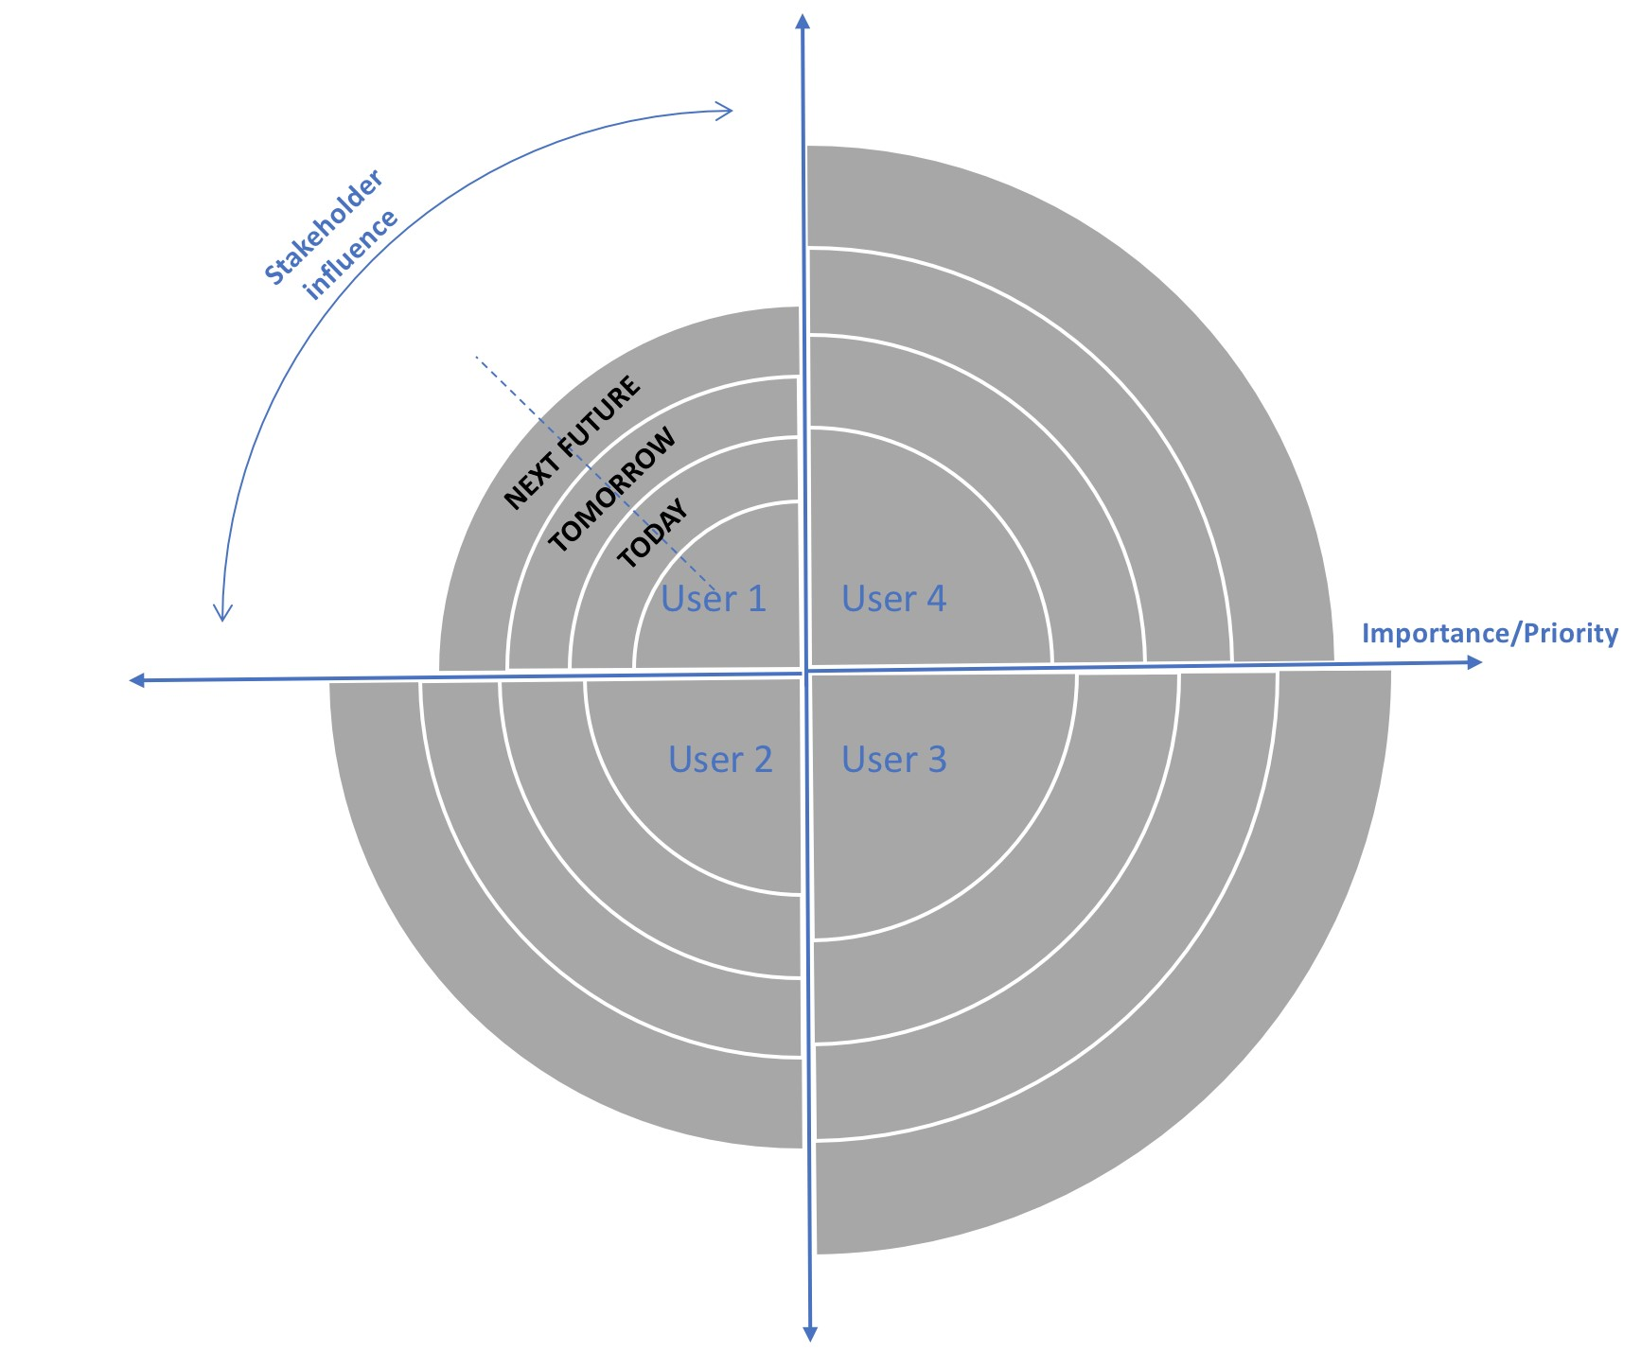

Figure 3.2. Value ring

## 3.4 Business Model Canvas

The Business Model Canvas (BMC) is a well known instrument, especially in the start-up world, developed by Alexander Osterwalder to describes the companies business model, the logic according to which an organisation creates, delivers and captures value [71] and contains all relevant information to develop new business ideas, create innovative startups or relocate existing businesses. The graphic template makes it is easy to visualise and define the company’s business model as a whole, allowing hypothetical scenarios and assessment of possible trade-offs between the elements that make up the system.

The model is made of 9 key elements that show the logic by which a company wants to make a profit. The nine elements belong to four main areas of a business:

* Partners
* Activities
* Resorces
* Value proposition
* Customer relationship
* Channels
* Customer Segment
* Cost structure
* Revenue stream

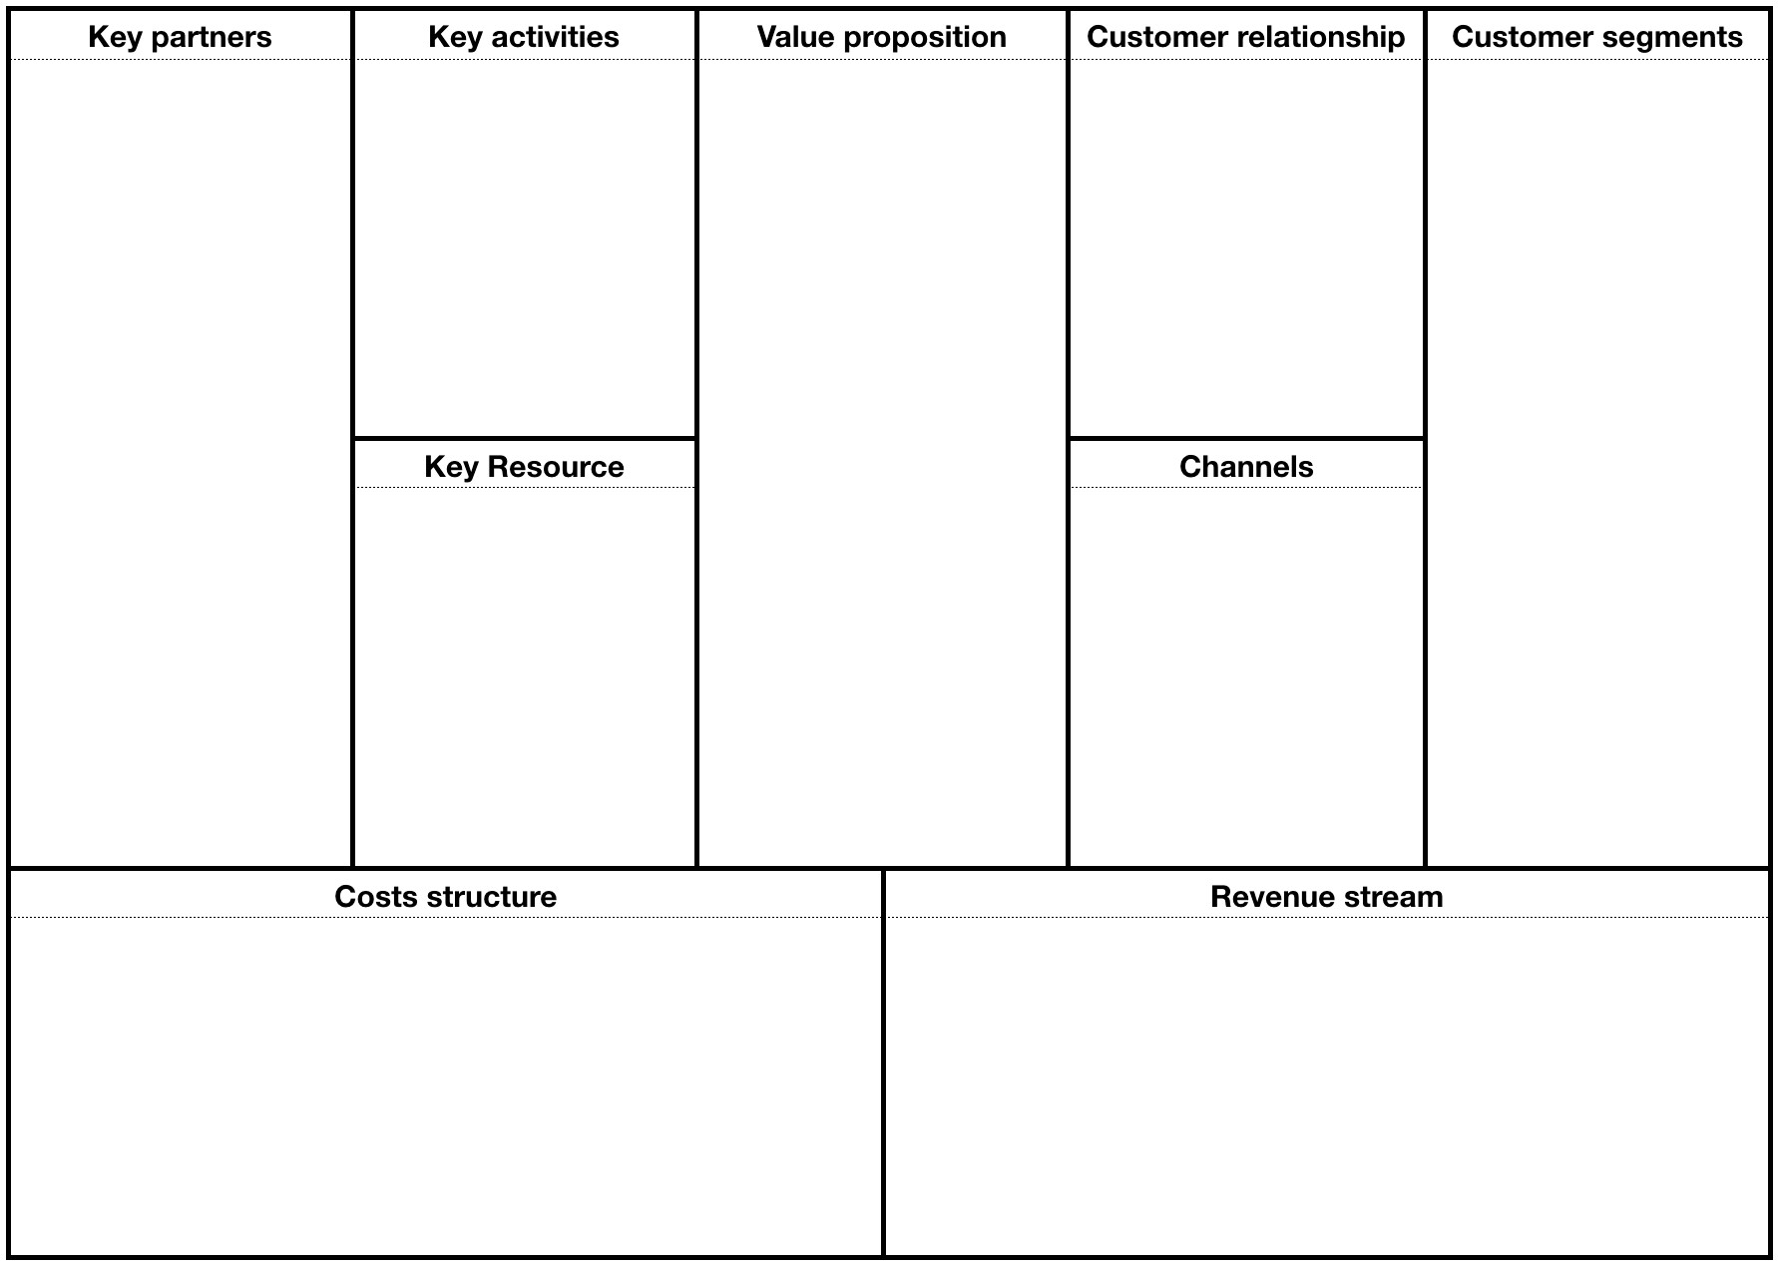

Figure 3.3. Business Model Canvas ( BMC )

Partners block describes the network of partners and suppliers essential in running the company’s business model. Conceiving the company as a system that operates within a larger ecosystem, it’s not possible to think about it as ’self-sufficient’. There are in fact strategic actors outside of the company who are essential to implement the business model and to increase the chances of success in the market. The partnerships may be of different types:

* Strategic alliances between non-competing companies: it’s the case of suppliers or companies that are confined to a single production chain;
* Strategic alliances between competitors: it’s the case of companies that are on a network to provide clients with a similar value proposition within various points of contact;
* Joint ventures between companies to develop new business;

Activities block describes the strategic activities that must be performed to create the Value Proposition, reach customers, and generate revenues. In other words, this block details which are the most important processes that the company has to manage to fulfil its own business model. As for key resources, key activities differ according to the industry: for a consulting firm a key activities relate to providing good advice to clients, for a food company a key activities can be identified with the production process. Key activities therefore can be of three types:

* Productive. They are typical of manufacturing companies for which it is essential to continuously create, produce and distribute the products;
* Problem Solving.They are typical of the service industry;
* Maintenance/development of platforms and networks. This is the case of companies like Google.

Key activities listed in the BMC should be the ones that determine a competitive advantage. Along with key resources and key partners, the key activities block will determine the structural costs that the company has to sustain. It’s good to keep a clear and concise overview of the business model, to facilitate the translation of the Business Model Canvas into strategic planning documents.

Resources block encompasses the strategic assets that a company must have to implement their own business model. Each activity has its own key resources:

* Physical. It includes tangible property such as stores, facilities, technologies and machinery;
* Intellectuals. It includes the know-how of a company, its patents, trademarks, copyrights, projects developed, partnerships and customer database;
* Human. Human resources are important in every business model, especially in the service industry. When working on the BMC it’s important to define which human resources are considered strategic;
* Financial. They include specific financial assets such as lines of credit, cash or a combination of stock options which enable the company to hire strategic employees or to secure supplies which constitute a competitive advantage.

When designing this block of the BMC it’s important to focus on those resources which create value for a specific customer segment.

Value Proposition is an array of goods and services which create value for a specific customer segment, and is the reason why customers go from one company to the next. The Value Proposition solves a customer’s problem and meets his needs through a specific mix of elements. The value can be quantitative (for example, price, speed of service) or qualitative (design, customer experience).

Customer relationship block describes the relationships established by the company with each of its customer segments. There are several ways in which a company can ( in accordance with its business model) engage customers:

* Personal Assistance
* Dedicated Personal Assistance
* Self-service
* Automatic Services
* Community
* Co-creation

At the operational level, it is important to understand which types of relationships can be strategically integrated with the business model that is being built and what kind of relationship is more suitable to each of the customer segments identified.

Channels represent the way a company interacts with its customer segments to deliver its Value Proposition. Communication, distribution and sales channels make up the interface of a company towards its customers. Channels are points of contact and therefore play an important role in creating a satisfying customer experience. Channels can be direct or indirect. The channels which are independently operated by the company are direct, such as sales force or a website, while channels such as a retail stores owned or operated by a partner are indirect. Indirect channels lead to lower profit margins, but allow organisations to extend their reach and to benefit from the strengths of their partners. Direct channels guarantee higher margins, but may require considerable costs for their activation and operation.

Customer Segment define the different groups of people or organisations that a company wants to reach and serve. Customers are the source of survival for every business: without profitable customers the company has no reason to exist. Therefore, it is vital to pay special attention in satisfying the customers’ needs and demands in the best possible way. To do this it’s necessary to group customers into distinct segments based on their common needs, behaviours, or other characteristics. These segments can be large or small, as long as they are identified correctly.

Costs structure block defines the costs that the company sustains in order to run its business. In the design process of the Business Model Canvas, the business’ cost structure is the last element to be defined, as it is directly related to the previous blocks of key activities, key partners and key resources. For certain types of activities, keeping the costs down is critical to being able to deliver value, for other activities it is not so important as their value proposition is based on status, innovation, and so on. Analysing the cost structure, the business model can have:

* Fixed costs - in this business model the costs remain constant regardless of the volume of goods and services produced (rent, salaries, production plants);
* Variable costs - costs vary depending on the volumes of goods and services produced;
* Economies of scale - costs decrease when a company expands;
* Economies of scope -costs decrease by increasing the scope of an operation;

When designing the cost structure block it is important to pay attention to key resources, key partners and key activities and to question which of these will cost more and if there are suitable alternatives or whether those costs are necessary to achieve the expected value. High costs must then be compared with the revenue streams: the business model is sustainable only if the latter are higher.

Revenue stream block describes the flows of revenues received by the company via the sale of products or services to a particular customer segment. The variables to be considered here are the price and the payment method, both critical to regulate financial flows. The price variable is a critical element in building a business model but, as mentioned earlier, it’s certainly not the only factor in making the model functioning and sustainable. The payment method completes the business process design and adds to the Revenue Stream block some critical information. It’s important to complement the information provided by the customer with in-depth market analysis, in order to have a benchmark with competitors.

## 3.5 Solution Canvas ( SC )

The Solution Canvas (SC) is an analytical tool used in the GUEST methodology with the intention of outlining the chosen solution. This document was inspired by the BMC [71] , so that the different steps are the direct consequence of the previous tool. If the BMC is the company ’as is’, the SC is the company ’to be’, focusing on the solutions that have been studied and designed thanks to the implementation of the previous step. The SC is divided into 9 sections, like the BMC:

* Decision makers: identifies who makes the decisions listed in the solution presented, their hierarchy and possibly the timing;
* Constraints: the actions necessary to implement the solution are detailed in this section, how they will be carried, their target and any technological constraints;
* Decisions: this section lists the decisions taken and to be implemented, specifying their characteristics, any hierarchy and methods of implementation;
* Information / Resources: indicates the source of the information that led to the solution chosen. In this section is also specified the level of detail of the information available and the level of uncertainty, as these two elements have a direct impact on the final objective;
* Users / DM Report: it describes the relations that exist between those who took the decisions and who will make use of them;
* Users: indicates the stakeholders involved in the solution, those who will benefit from the solution implemented. Users play a vital role, just like the one covered by the Customers in the BMC. Change in a business context is a very sensitive factor that must be managed with care and competence. Users, in this case, are the protagonists of change and therefore will have to be fully involved in the process, guided and supported by decision makers to avoid dangerous phenomena of resistance at the corporate level;
* Channels: it defines the channels through which different actors are informed of the change due to the solution chosen and the channels through which the solution is implemented;
* Goals: explicit objectives to be achieved thanks to the solution defined on the basis of KPIs identified in the previous Evaluate phase;
* Costs: in this section must be listed the set-up costs to implement the proposed solution and its maintenance costs. It is also important to stress negative and / or positives effects on other business aspects. In this section, we will also be introduced the ’no cost’ solution, or the negative impact that the company would incur not implementing the such solution.

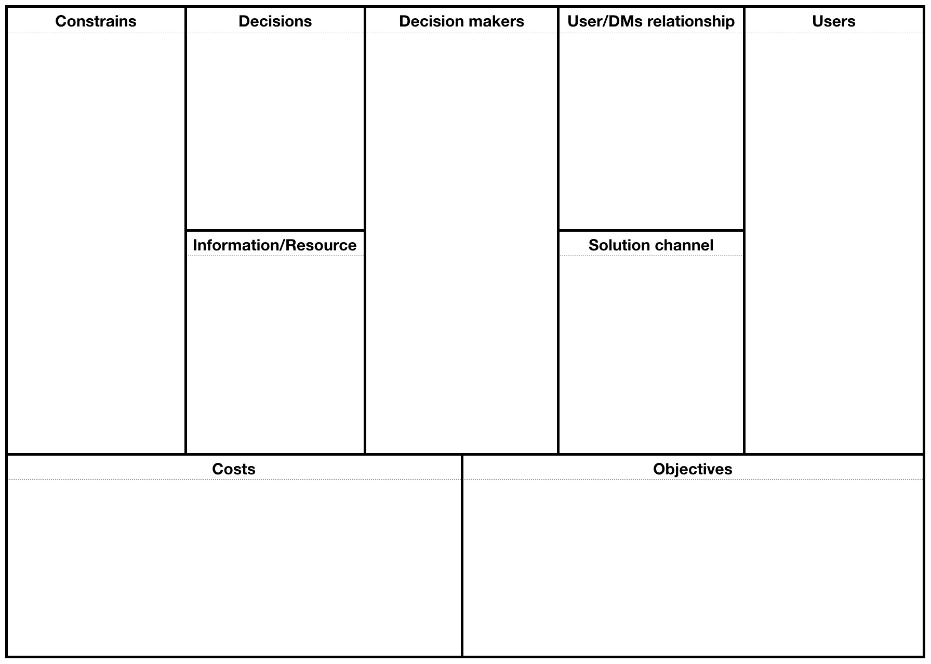

Figure 3.4. Solution Canvas ( SC )

Chapter 4

# Blockchain-based automotive supply chain analysis ( AS-IS )

## 4.1 Hypothesis

At this stage of the dissertation we have focused our view to the automotive supply chain. This choose it’s not casual but it’s the outcome of different factors coming from the analysis, as we will see, and from the lack of use cases in literature. We will develop the use case as an external actor willing to enter in the market as a service provider for this reason all the actors will be managed as customer of the service. With this hypothesis the analysis is suitable for different scenarios in which the new business could be managed from a 3th party, an internal actor as the car manufacturer or in the best case by a consortium between different players.

## 4.2 Limitation

We are not going to go deeply in every part of the process, but we will prefer to have a complete overview of the interactions of the main actors between them and with the new service we are going to introduce in the market. For this reason we will consider a light supply chain (figure 4.1) involving only: OEMs, transportation and storing, grouped in one entity as logistics, car manufacturer, retail and mechanician grouped in one and one kind of customer. All the tools used in the analysis are the results of many iteration as suggested by Alexander Osterwalder [71], we will present only the final outcome.

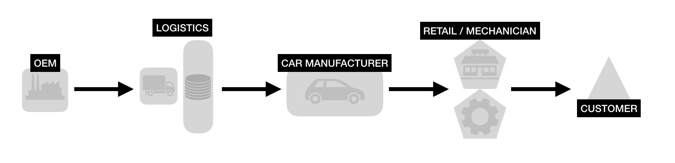

Figure 4.1. Reduced automotive supply chain

## 4.3 Market/Technology analysis

In the market analysis which substitute the interview phase in the adapted GUEST, we are going to analyse the automotive supply chain, from an internal perspective. Moreover we will take advantage in the development of the analysis by an estimation of the grey parts market and costs related to parts recall, which as we already said will be mitigate by blockchain thanks for its transparency and efficiency.

### 4.3.1 Blockchain in Supply chain

Blockchains are currently being used to solve problems in supply chain management by eliminating the need for a trusted third party to certify raw materials, components, or finished products, as they travel through a supply chain. Every participant, or node, contains a copy of all transactions. This provides an audit trail of every transaction that has occurred in the system. A change would be validated or rejected by the nodes in the system. Because all participants have a copy of all past transactions in the network, any participant can detect if a product is not as advertised. Instead of examining raw materials, components, or finished products at several points in the supply chain, a record of the inspection would be available and bound to the item as it flows through the supply chain. Although a record of the transaction is public and tied to the movement of physical items across the network, specifics such as the quantity of goods, or the identity of the parties transacting, can be done pseudo-anonymously in a blockchain. Such a granular view of movement through supply chains improves resource allocation [85]. The trade finance industry can also leverage information visible in a supply chain blockchain. In its broadest sense, trade finance manages capital required for international trade. Trade financing has become the norm for cross border transactions, with the World Trade Organisation estimating that "up to 80% of global trade is supported by some sort of financing or credit insurance" [57]. An exporter needs to to mitigate the risk of non-payment, while an importer wants to mitigate the supply risk. The function of trade finance is to act as a third party to remove the payment risk and the supply risk, whilst providing the exporter with accelerated receivables, and the importer with extended credit. Institutions that provide capital during these trades can leverage the information visible in a supply chain blockchain to better evaluate companies for lending.

### 4.3.2 Automotive supply chain

In this section we analyse automotive supply chain to put in evidence weakness and future challenges. In making this we will use a survey by IBM “Global Chief Supply Chain Officer Study“ analysing it to find interesting insights.

Currently, automotive companies are stuck in a worldwide industry transition. At the center of this massive change is the automotive supply chain. Companies will need to understand how to manage co-creation of their offerings together with suppliers or buyers, and the service supply chain becomes the new research topic in supply chain fields [33].

An important source of information is given by the survey made by IBM about worldwide companies supply chain. The study is conducted face-to-face interviewing nearly 400 senior supply chain executive [34]. Supply chain executives told that the main challenges for SC could be synthesised in 5 group: visibility, risk, cost containment, customer demand and globalisation. We will focus only on the 33 supply chain executive from automotive companies, including suppliers, truck and heavy equipment OEMs, light vehicle, and service providers. Not surprising the 66% addressed cost containment as prominent on the automotive agenda, with a sensitive difference with the all industries percentage as shown in figure 4.2. Visibility ranks even higher with 81% of responses and really interesting is the lack of significance placed on risk management.

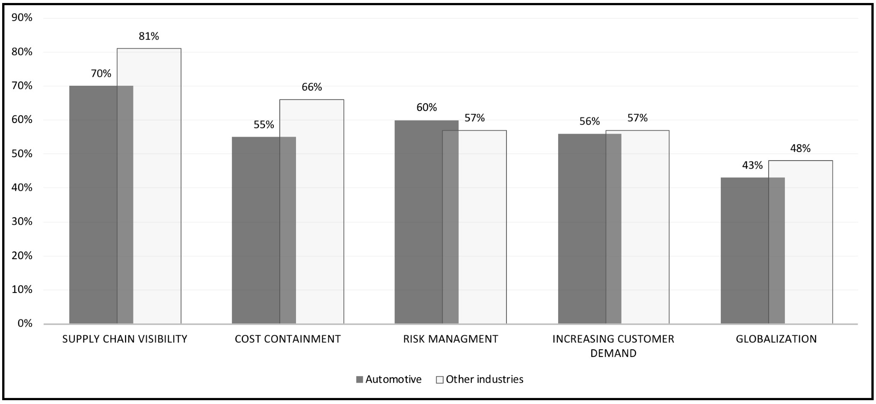

Figure 4.2. Main challenge for supply chain executives

Automotive supply chain results less effective in sharing real-time demand and inventory time compered to other industries. Only 5% of automotive executive has an effective real-time supply chain against 25% of other industries [34]. Surprisingly, however, the responses across industries suggest that the most significant barriers to visibility and collaboration are organisational, rather than technological. Automotive executives agree, with organisational silos cited as the primary obstacle (Figure 4.3) [34].

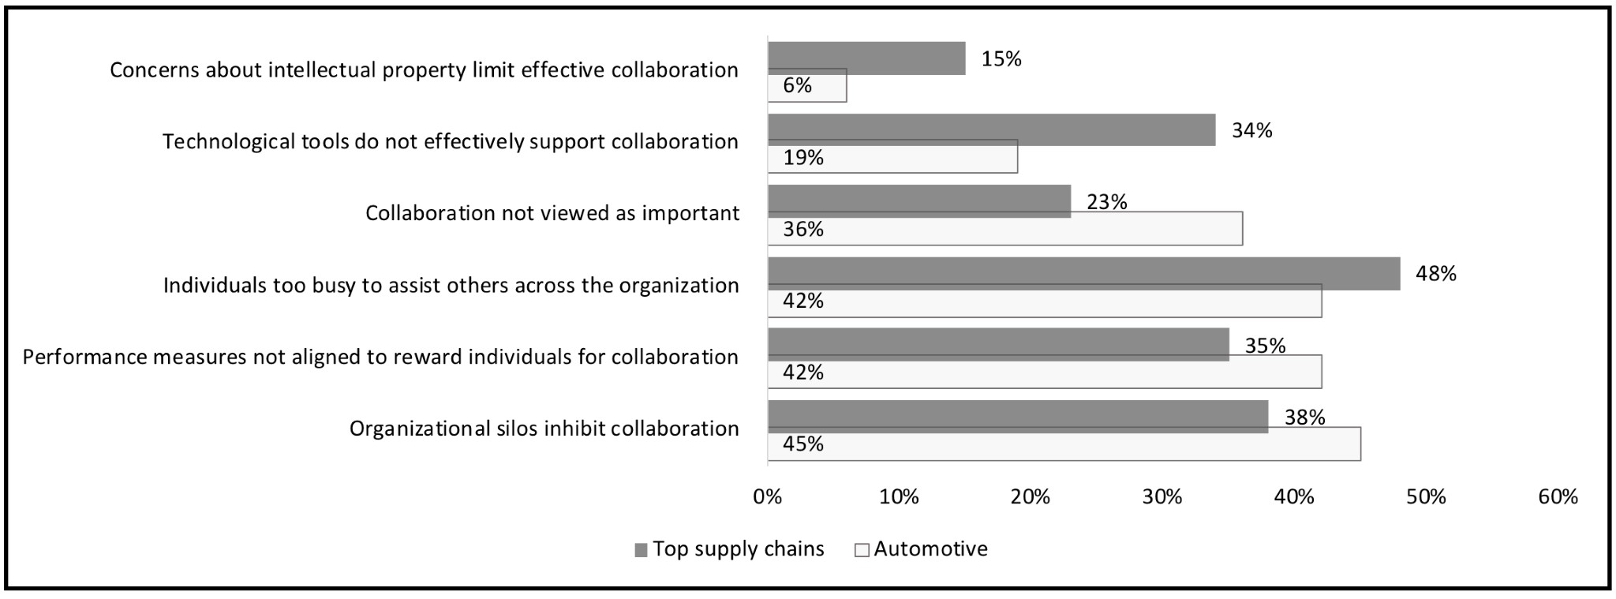

Figure 4.3. Main barriers for supply chain visibility

The survey suggest outsourcing is one potential area of opportunity to variate costs. The only supply chain function that is extensively outsourced by the majority of automotive executives is transportation (76%). Only one in five reports widespread outsourcing of customs/export management and warehousing/distribution centres. Less than 5% use contract manufacturing. And not a single automotive executive reports extensive outsourcing of procurement [34].

Automotive supply chains also have room to improve outsourcing effectiveness. Even in areas like transportation, which 95% [34] of automotive companies outsource to some extent, the industry’s effectiveness lags that of top supply chains. The gaps are larger in areas that require more flexibility and advanced analytics capabilities, such as differentiated logistics services and network optimisation.

Product recall

In the US alone about 37m vehicles from different manufacturers, like General Motors, Ford and Toyota, are under recall because of defective airbags made by the Japanese manufacturer Takata [80]. And the trend is increasing, natural outcome of cutting cost initiatives. Product recalls can be very expensive. When automotive companies can’t pinpoint the exact vehicles that need to be recalled, they have to overcompensate to protect consumers. They alert people with certain models to take their cars in for a fix and the costs associated with that are enormous. According to research from German insurer Allianz, the average value of large recall claims in the automotive industry is €10.7M [80]. Going into details automakers and suppliers paid almost 11.8 billion dollar in claims and recorded 10.3 billion dollar in warranty accruals for U.S. recalls in 2016. The increase was 26% over the previous year with an estimation of 22.1 billion dollar [79]. Moreover based on the data from Statista, the two off the four parts mostly recalled in 2016 were the airbags and seat belt [89]. Car manufacturer choose to recall generally speaking only safety related or fundamental part of vehicles, for this reason we don’t have insights about target substitution.

### 4.3.3 Counterfeited product

Last year, over 500,000 counterfeit car parts were seized in a raid in Abu Dhabi. Valued at over 5.4 million dollars, the fake parts were supposed to get shipped to Australia [78]. The automotive industry is severely affected by the ploys of counterfeiters. Both the market for original automotive components (OEM, Original Equipment Manufacturer) and the free spare parts market (IAM, Independent Aftermarket) are affected by product counterfeiting and grey market trading. The counterfeiters focus especially on small-scale spare parts and automotive components such as piston rings, filters, seat belts, brake pads, spark plugs, hoses and glow plugs. But also products such as windshields, brake disks, windscreen wipers, car batteries as well as oils and lubricants are faked [77]. The authenticity of components and spare parts is crucial for vehicle safety as counterfeit products do not conform with the quality standards. If an accident is caused because, for example, the counterfeit brake disk is faulty, then this is acutely dangerous. Additionally, there are also serious financial drawbacks. Through trading with counterfeit products and illegal overproduction or grey market trading, manufacturers of original parts are confronted with high financial losses. The purchasers of fake products suffer as the installed fakes have different performance. For manufacturers, there is also the loss of image which arises when the poor quality spare parts are mistaken for originals. Moreover if an accident occurred because of a counterfeit part or a part bearing a counterfeit make, the insurer would be within its rights not to assume liability or reimburse the losses.

Business volume

The estimation of the global loss to motor vehicle suppliers because of counterfeiting could be as high as 45 billion dollars in 2011 [75]. In Europe, 73% of fake goods came from China in 2011, according to a report on EU customs enforcement. In the report the European Commission recorded that fraudulent vehicles, parts and accessories worth a retail value of €27M were seized. Around 68% were from China (including Hong Kong) and nearly 25% from the United Arab Emirates (UAE) [75]. Yet very few manufacturers have adequate end-to-end visibility of parts entering and leaving their supply chain. They might be able to see one or two steps upstream, but for the most part, they don’t have visibility beyond their immediate vendor. And when visibility is lacking in a supply chain, counterfeiters flourish [79].

### 4.3.4 Traceability issue

The main issue of improving traceability is that the perceived or economic benefits of traceability have to outweigh the costs of the system. Companies are only interested in improving traceability only if it can add value to the customer or reduce operational costs for the organisation [61] . Traceability efforts will decrease profits if the information gathered from the traceability system fails to reduce costs, or fails to communicate added value to the consumer. According to Saak [62], an implication of this is that mandatory traceability might decrease social welfare, and explains: “This happens if the downstream firm can build a reputation for high quality in the no-traceability regime but not in the traceability regime, or if the downstream firm prefers to exit the market for high quality because of the negative effects of traceability on profits”. Summarising the main problems related to traceability, we may face [63]:

* Standardised formats - there is a lack of standardised formats between entities in the supply chain, especially between countries with different regulations. There is a huge need of standardisation
* Trustworthy information – paper is still used as a cheaper alternative to digitalised and more trustworthy databases, creating foggy business.
* Traceability of bulk produce - challenging to trace through internal processes.
* Organisational hurdles – transparency and confidentiality of information must be balanced between traceability parties.
* Technological hurdles – not all traceability parties have the required software or hardware for internal traceability, and software integration and interoperability between parties is often limited.

This consideration, as we will see, is very important in business like maintenance experts at the end of the value chain who doesn’t have a clear business and the traceability value is substituted by the brand. However main difficulties are the technological hurdle and the manual exchange of information between parties.

## 4.4 Social Business Network SBN

We choose to develop the analysis with six main actor:

* Regulators
* Suppliers
* Car manufacturer
* Logistic
* Retailer/Mechanician
* Customer

Below we sketch the Social business network in figure 4.4, considering the linked legenda in figure 3.1.

Figure 4.4. SBN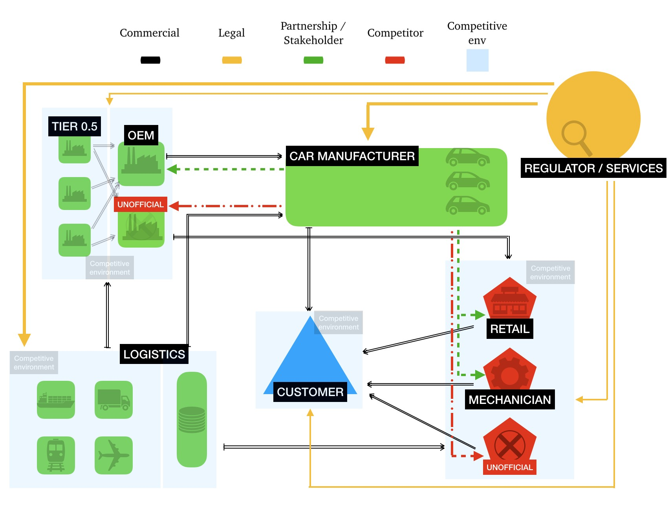

## 4.5 Value Proposition

In this section we are going to develop the value proposition for every actor in the network. We will highlight gain and pain which will be linked to a blockchain attributes and jobs which will be linked to a service.

### 4.5.1 Suppliers/OEMs

Suppliers are expected to face many challenges going forward: The slowing growth will put pressure on margins and create a need to find new ways to grow, obviously they will need to address the technological change which requires further investment into new technologies [67]. The investments for sure will change the competitive landscape, trying to solve old issues in the market to boost profitability and open to new business opportunities. According to a survey by PwC about Automotive Supplier from 2017 [60] main CEOs of automotive suppliers answered that the technology which will be of the highest strategic importance in the next five years is robotics with 93% of respondents. Important to notice is that digital solutions growth from 25% of 2016 to 89% of 2017. Digital factory topics are increasing their importance, like the data mining opportunities, answered by 82 % of respondents. Cybersecurity is important for 48% of respondents, the value is dubled from 2016 [60]. With the growing number of product variations and the pressure to make production more effective, industrial companies are increasing their use of solutions known as Industry 4.0. While in the past, companies expected to use Industry 4.0 technologies in the future, now one fifth of the companies surveyed stated they are currently using them, and about the same number of companies expect to use them within two years. Less than 30% of the companies expect to use them in more than five years, while about one quarter of the companies still do not have any information about the application of this innovation [60]. For the development of our analysis

Trying to have a wide view of suppliers and OEMs pains, one important role is covered by MRO (maintenance, repair and operations). A critical component of any firm’s MRO inventory is spare parts management it is creating numerous challenges for the companies that maintain it. When asked about the problems related to spare parts inventory, 42 % of respondents said their parts and consumables inventory tracking needed improvement, while another 42% claimed downtime was their biggest spare parts issue. Other responses included difficulty finding the parts or solutions needed (21%), and having a tough time understanding parts and consumables usage patterns (20%) (figure 4.5) [82].

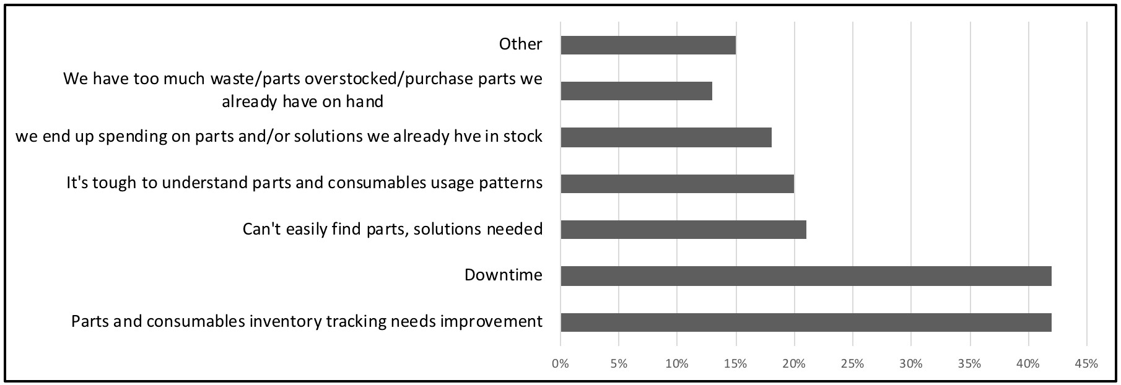

Figure 4.5. What are the most common problems you experience with spare parts inventory?

Value proposition

Suppliers and OEMs will have the most important role as they are the first block of the chain. They have probably the highest bargaining power in the network and their needs will be fundamental in shaping the business. We saw that currently there are many OEMs which are testing new ICT technology to boost their revenue with the connected car. Blockchain will be the key to solve the security issue related to IoT sensors and privacy. Moreover the blockchain will solve many of the problems put in evidence in the surveys, like maintenance management, parts tracking. The great amount of data enable data gathering and process optimisation, opening up to new business opportunities as target recall of fault parts or improvements in design. Thanks to parts verification they will avoid jeopardisation of grey parts. This will increase their product and brand value against competitor. The threat is the increased workload. Probably they have to adapt their process to the new technology and introduce new technologies in their product which will increase their costs.

Table 4.1. Suppliers value proposition

SUPPLIERS

|  |  |  |  |
| --- | --- | --- | --- |
| Gain | Lean production, Product value, Access to data, Revenue, Flexibility, Efficiency, Economies of scale, Product lifecycle visibility | Gain  Creator | Quality, traceability, improve efficiency |
| Pain | Costs, Competition, Resources availability, Work pressure, Customisation, Supply chain complexity, Counterfeit product, Litigation, Bullwhip | Pain  Reliever | Efficiency, Speed, Cost savings, Know your supplier, Real time data |
| Jobs | Lean production, Increase profit, After sale services, Improved design, | Product  Service | Parts identity management, Target recall, Know your supplier, Track provenance, Connected supply chain. |

### 4.5.2 Car manufacturer

Many of the consideration made for suppliers and OEM could fit car manufacturer ones, in fact most of the time they are managed by the same corporation. This trend of vertical integration is the natural outcome of the high importance of the commercial agreements between OEM and car brands. The main difference is that the assembly of a car involve many parts, which can come from all over the world. It’s an high complex task, and the supply chain tracking and visibility will solve many business problems. For car manufacturers, the next five years will be fundamental, the 30% of respondent think they should address industry 4.0 methodologies within 5 yers from now. This percentage has grown considerably from the 13% of 2016, and only the 3% think they should not think about process digitalisation. Moreover the future will offer many technologies that are growing nowadays to boost process and revenue. An important issue will be cybersecurity for the 48% of respondents, but also robotics (93%) digital factory (89%) and data mining (82%) are the most promising.

Value Proposition

Car manufacture is the business player who will benefit the most from the adoption of blockchain in the automotive industry. The first outcome of blockchain application will be quality for the customers, increasing the brand value. Traceability and data access will help resource management. Immutability of data and privacy will help in litigation and target recall. Moreover the blockchain adoption will not modify heavily their workload, but it will increase services for customers and source of revenues.

Table 4.2. Car manufacturer value proposition

CAR

MANUFACTURER

|  |  |  |  |
| --- | --- | --- | --- |
| Gain | Revenue, Flexibility, Product lifecycle visibility, Data, Brand value, Lean production | Gain  Creator | Traceability, Quality, Efficiency |
| Pain | Counterfeited parts, Competition, Litigation, Customer privacy, Time to market, Bullwhip | Pain  Reliever | Immutability of data, Quality, Security, Transparency,  Real time data |
| Jobs | Lean production, Increase revenue, Reduce counterfeited products, Meet customer needs | Product  Service | Target recall, connected supply chain, track provenance, parts identity management, Connected supply chain |

### 4.5.3 Logistic

Fluctuating capacity, increased shipper demands and disruptions within the industry are creating a volatile decision-making environment for shippers and logistics providers trying to optimise the supply chain. Both parties are increasingly using information and analytics to drive their decisions. To help optimise the supply chain, shippers are becoming less concerned about the mode of transportation and instead are opting for the most efficient means of moving products. That has resulted in the growth of mode-neutral logistics providers, and 3PLs are using data aggregation and analysis to determine the best shipment methods. Nearly three-fourths of shippers said real-time analytics from 3 PLs help them better understand shipping alternatives. To provide increased information and data driven solutions, 3PLs are broadening service offerings, and turned to mergers and acquisitions to fill gaps in service areas and technology [68].

Among 3PLs, only 23% said their shipper customers find a guaranteed mode to be the most important factor and 38% of 3PLs said their customers are most concerned with the shortest shipping time. Instead, 77% said shippers want the lowest cost, and 75% said their shipper customers are the most interested in a guaranteed arrival date as shown in figure 4.6 [68]. In this landscape is clear as the logistic is still focused in cost reduction, but it’s stuck in the complex supply chain that comes from the outsourcing trend, with data integration, visibility and demand forecasting problems.

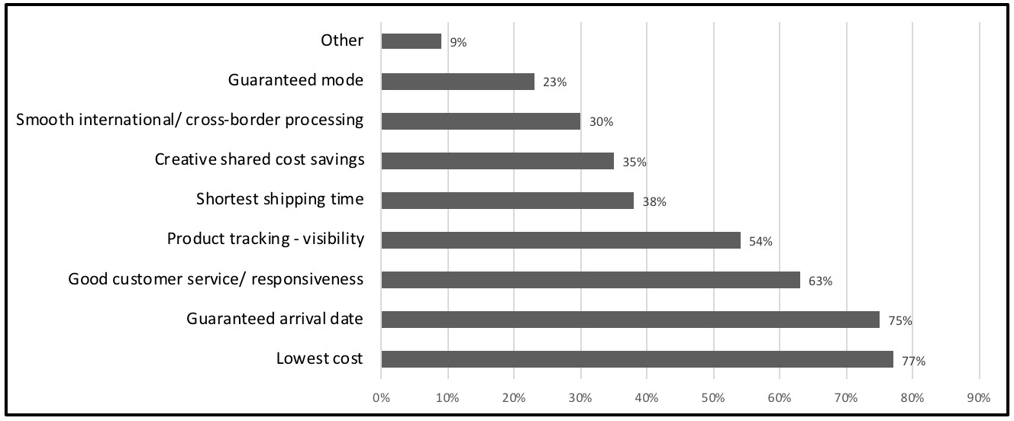

Figure 4.6. 3PL/4PL respondents’ views on service providing in 2016, ranked by the most important factors to shippers

Value proposition

Blockchain is a great opportunity to standardise the logistic process. Traceability and instant data access will give a competitive advantage to carriers limiting the bullwhip effect. Document automation and efficiency will boost speed and lead time. The whole process will be more structured and less flexible during the adoption first step, but the reward will be fair. The blockchain will open new business possibilities like easy and integrated subcontracting and new insurance models. Moreover the connected supply chain is already a need for the business, with the continuous endeavour to boost the efficiency of process. Blockchain will have enormous externalities in the logistic for resource allocation and optimisation to reduce costs.

Table 4.3. Logistic value proposition

LOGISTIC

|  |  |  |  |
| --- | --- | --- | --- |
| Gain | Revenue, Flexibility, Economies of scale, Integration | Gain  Creator | Transparency, Speed, Equitable access, Efficiency, Standardisation |
| Pain | Lead time, Costs, Competition, Documentation, Work pressure, Transportation failure/delays, Litigation, | Pain  Reliever | Traceability, Speed (document automation), Real time data |
| Jobs | Lean process, Reduce time, Reduce risk of delays, Planning | Product  Service | Verification, Smart contracts, Track provenance, Connected supply chain |

### 4.5.4 Retailer/Garage

Retailer and garage profits comes manly from maintenance and used car reselling. About the latter, as shown in figure 4.7, they are preferred among websites and privates. Data from statista [89] show that there is still needs of physical store, online selling of second hands cars in fact account for about 35%. This suggest that the added value of the used market is certification, instead price (figure 4.8). This insights comes out even when considering the maintenance. The 70% of respondents answered that a free oil change and maintenance will influence the choice of buying/leasing a car. What is clear is that customer doesn’t want to take care of the maintenance of their car. This is a challenge for retailer, garage and aftermarket specialist. Probably the latter will lose their margine if they will be not able to offer a quality product. The car manufacturer will likely try to vertical integrate their process, to have more control on retailers.

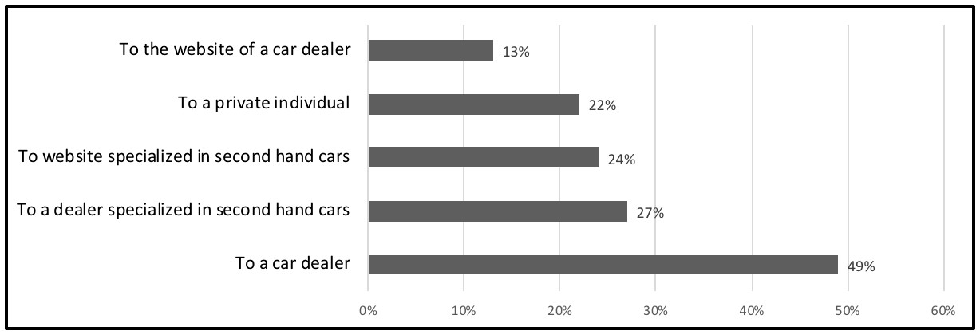

Figure 4.7. Where you would like to buy a 2nd hand car in the future

Value proposition

Retailer and garage are at the end of the value chain. They are the one with less bargaining power in the network. Many of them are car manufacturer partners, and they will benefit as well of the quality and process improvements. Unofficial ones will be forced to modify their business or cut their margins. The technology will help those who are willing to act in a fair way allowing the purchase and installation of only verified parts. Probably there

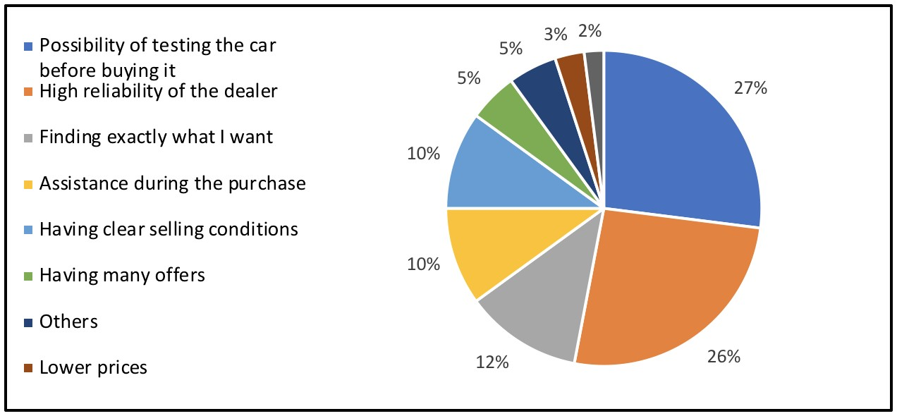

Figure 4.8. When choosing your preferred sales channel of used cars, what matters for you the most?

will be no need anymore of used car retailer as the vehicles certification and warranty will be provided by the blockchain due to the increased control in the value creation by the car manufacturer. Blockchain will uncover many not lawful business as their service will be more clear and traced. This brings to a service coverage issue which car maker and OEMs have to address.

Table 4.4. Retailer/Garage value propositio

RETAILER

/

GARAGE

|  |  |  |  |
| --- | --- | --- | --- |
| Gain | Easy and Target maintenance, Revenue | Gain  Creator | Traceability, Quality, |
| Pain | Competition, Costs, Work pressure, Resource availability, Market modification | Pain  Reliever | Quality, Efficiency, Transparency, Equitable access |
| Jobs | Lean process, Reduce time, Resource management | Product  Service | Target maintenance, Track provenance, Parts identity management |

### 4.5.5 Car owner

Drivers and passengers increasingly expect access to connected services in their vehicles. The connected vehicle space is a fast-growing market and a strategic priority for the Automotive Industry. At the same time, the diagnostics data that these systems generate can provide OEMs with the insights they need to enhance services in areas such as CRM/marketing, quality, customer services, after sales and R&D but firstly increase the quality of the service offered. Based on the data from the website Statista [89] car owners totally agree that the future car have to be safety (73,3% of responses), and that the main trad-off to share their data is to receive in in exchange proactive maintenance. This data about privacy is heavily influenced by culture. People are very aware of privacy issues in Europe compared Cina, but they will share their data for a price reduction (figure 4.9). This put in evidence as car owner are not willing to pay more for a better quality product, and are very price sensitive.

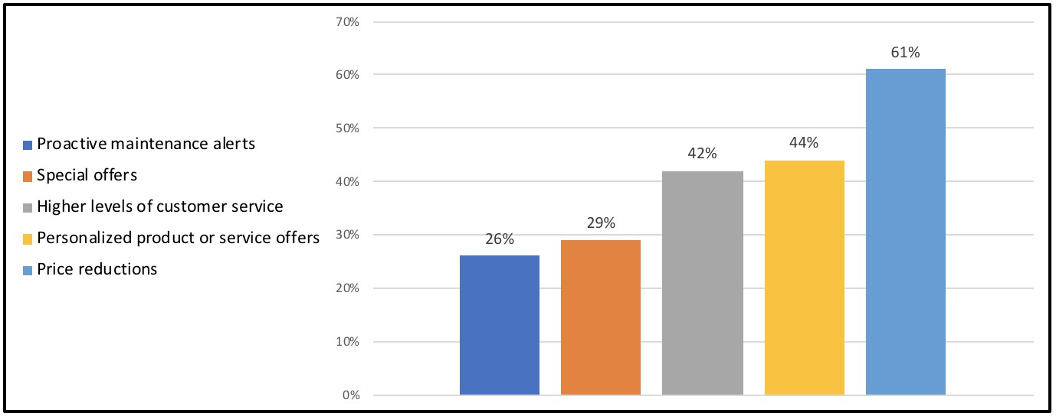

Figure 4.9. For which of the following customer service purposes are you willing to share your personal data?

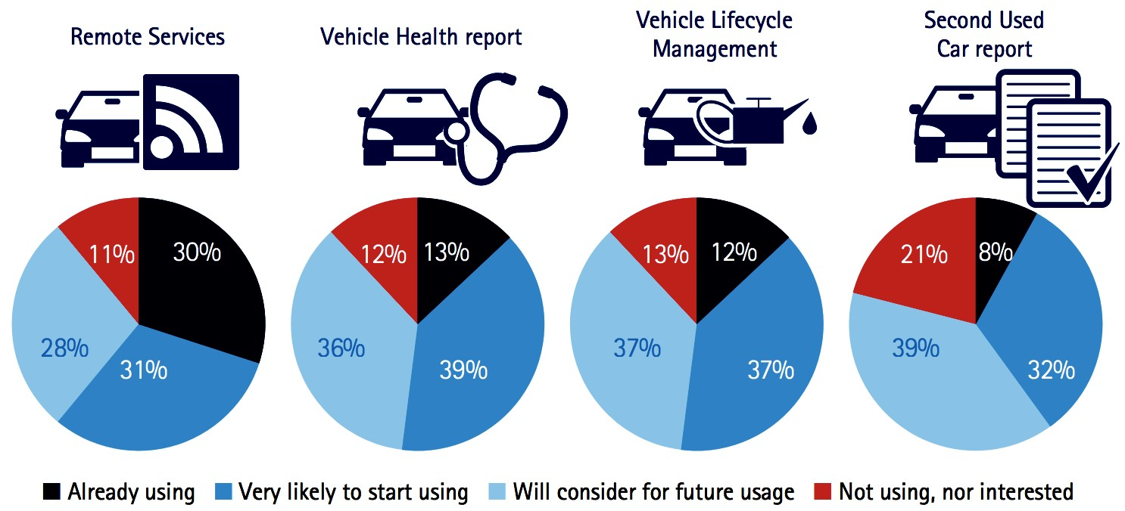

Figure 4.10. How important is to have the following service in your car

Focusing on car services, quite 80% of respondents will appreciate a stolen vehicle tracker [69]. The answer to the question about important services, suggested that the majority will appreciate services to decrease insurance costs using data on drivers behaviour instead services to activate commands remotely as shown in figure 4.10 taken from the survey from the consulting company Accenture [69]. A second hand car report will be likely used by 39% of respondents.

Value proposition

They are the final customer at the end of the value chain. Obviously the product have to meet customer needs firstly and in fact they will support all the blockchain applications proposed. Blockchain will regulate their privacy in the connected car and finance payments. In particular, financiers of car purchases would benefit enormously from such an accurate source of information, as the valuation of used cars would be much more accurate, allowing for better estimates of residual values and consequently resale values. Moreover, as analysed in trends section 1.2, in near future cars will need to increase their reliability, because they will include more and more complexity and feature of increasingly importance for customer safety. Quality will boost reliability of product and the immutability and traceability will increase their bargaining power avoiding inflated garage bills. All this value captured will be repay with customer data and new business revenue.

Table 4.5. Customer value proposition

CUSTOMER

|  |  |  |  |
| --- | --- | --- | --- |
| Gain | Quality, Warranty, Reliability, Customization, | Gain  Creator | quality, Traceability, Security |
| Pain | Prices, Maintenance, Services coverage, Depreciation, Privacy | Pain  Reliever | Traceability, Immutability, Quality, Speed, Privacy |
| Jobs | Reliable product | Product  Service | Track provenance, Parts identity management, Target maintenance |

### 4.5.6 Regualators/Sevices

Regulators are constantly forced to update their policies to meet their objectives. They are a fundamental part of the business process, especially for international trade. Many companies need a legal department to check if their product comply with regulations in all the countries in which they operate, to avoid unwelcome forfeitures. By the way, regulators have to support business avoiding counterfeited products and any breach of patent. This process is still managed in an old fashioned way, for the absence of a digital certification, but the blockchain give a great opportunity to automise, for example, customs stage operations. Moreover in this section we decided to include possible services. The creation of digital twin of spare parts will open to a great number of business possibilities, for sure they will be explored in a second phase, but this is the most promising field.

Value proposition

Regulators are probably the most interested in the development of a blockchain service in automotive. Many of its tasks could be supported by the blockchain which as we saw enable a regulation by design. Data accessibility will boost market analysis to introduce quickly public policies and have a clear view of the value chain. Moreover Blockchain will help in solving counterfeited products problem and litigations.

Moreover we choose to include in this category service provider. They are external actor who will enter in the network to create additional service, as it has already happened in mobile apps. Blockchain will support external application which can run on it to integrate new services and adaptability to business needs. Due to its open source nature, and regular API deliver and update, there is a growing community willing to take part in the development of the technology. Their value proposition is put in evidence with () in the table but will not take part in next analysis.

Table 4.6. Regulators/Services value proposition

REGULATORS/SERVICES

|  |  |  |  |
| --- | --- | --- | --- |
| Gain | Auditability, Certified provenance, Accessibility to data, Sustainability, (new business model), | Gain  Creator | Speed, Instant data access, (open source) |
| Pain | Counterfeited parts, Low control, Litigation, | Pain  Reliever | Transparency, Identity management, Immutability of  data |
| Jobs | Regulate, Public policies, Protect customers, Check provenance, Encourage sustainability, Cycle economy, Employment, (new service creation) | Product  Service | Track provenance, Parts identity management, Know your supplier, Digital twin, ( API ). |

## 4.6 Value Ring

In this section we summarise and prioritise the outcomes of the value proposition analysis. We organise them in a visual way with the help of value ring in figure 4.11. To help the sketching we are not going to use the circular version, but instead a composition of boxes of different color and size. On the vertical axe we find the actor importance/priority and on the horizontal we assume that all the actor have the same market influence.

The main objective to address in the relation between main players in the market (car brand, supplier/OEMs and Logistic) is the connected supply chain with real and certificated data. This will save many cost which is the most important objective for logistics. In a second phase, the data gathering will be expanded in more process to boost KPI monitoring and automated decision making.

On the other side customer are quite happy with the car product but new technologies represent a threat for privacy and safety that have to be addressed by regulators and car manufacturer. Additional services will be accepted only for a discount opportunity, and the vehicle certification will be a great added value for second hand car, but its not an urgent need. Retailers are the less important in the whole network. They will be affected by the market modification and their only objective is to proactive face the new challenge to maintain the market share and revenues.

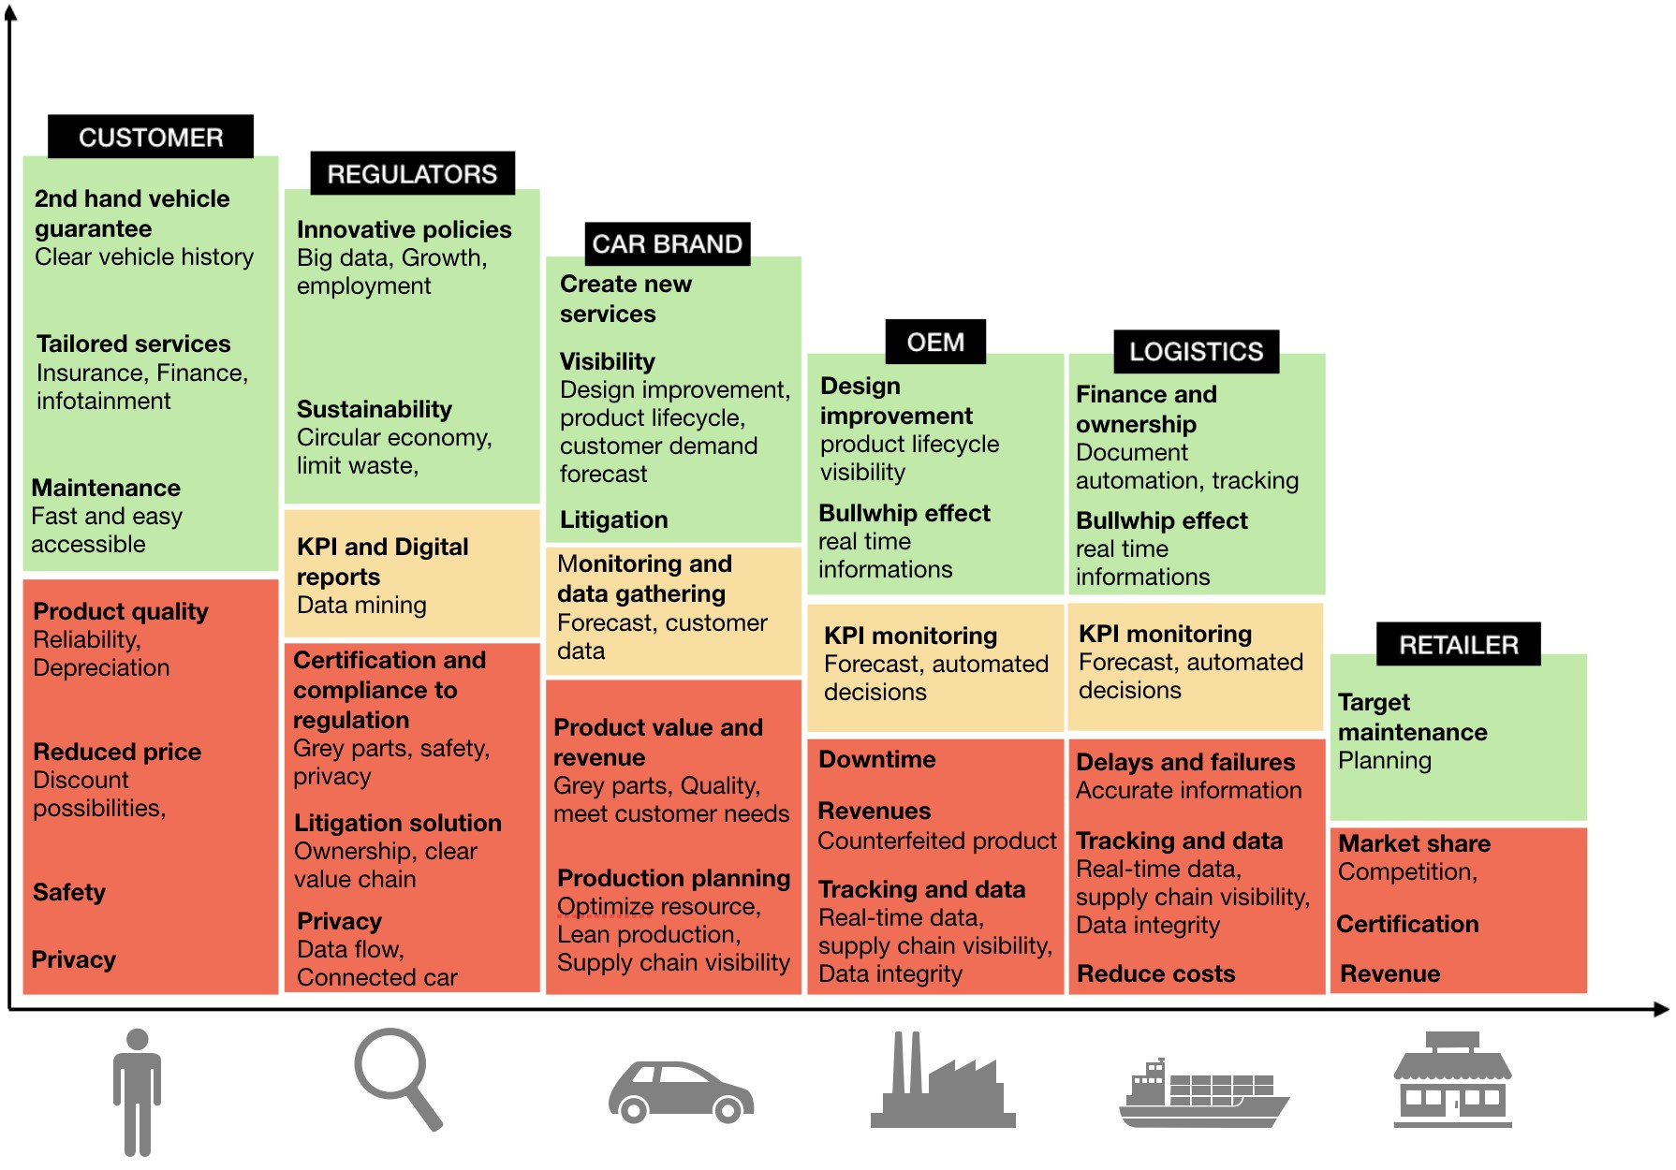

Figure 4.11. Value ring

## 4.7 Business Model Canvas ( BMC )

In this section we use the Business Model Canvas to sketch up an early business model. Below is described only the final version, outcome of many iteration. This is not ultimately solution, but could be a guide for future analysis.

Value proposition. The company offers specific and continuously improving services for the main players of automotive supply chain. We highlight four main value proposition already analysed during the section 2.4: Target recall, Connected supply chain, Provenance and verified parts.

Key activities. During the startup phase the key activity will be joining associations and community in the market to shape the service based on customers needs. The growth of actors joining the network will increase the overall value. Once the infrastructure will be running the key activity will be related to maintenance and ReD to improve the product. On top of this there will be the possibility to create new business and service from the great amount of data managed.

Key resources. The key financial resources of the companies are provided by the shareholders, who cover the salaries and overhead costs. Is easy to think that this kind of company could be created by the car manufacturer, which will be the main stakeholder for the many positive outcomes. Many resource will be outsourced and the key resource will be the team composed by expertise in the market and business developers.

Partners. The company is defined as a service provider, which will give support to the various player in the automotive value chain, managing a large amount of information about the process and an extensive network. The business have to establish several partnership in the market. Firstly with a cloud infrastructure provider as Amazon Web Service (AWS) or IBM and moreover with an IoT company which will provide sensors (GPS,RFID,..) to get data during the process. By now the core competence of the company isn’t software development, for this reason there will be need of hiring developers. Between partners we can cite regulators who will have a positive outcome from the service and will control issues related data security and privacy.

Customers. Every actor in the logistic chain is a potential customer of the company. As we already mentioned we grouped them in 5 categories: suppliers, logistics, car manufacturer, retail/garage , regulator and car owner. All of them apart car owner and garage should be customer and a partner at the same time.

Customer relationship. The relationships established with customers can be defined as partnerships. For this reason the company will establish a consortium, if possible, in which the main actor take part. The consortium adapts, modifies and innovates its services based on the requirements and feedback provided by strategic customers. In this perspective, the company facilitates and enables the development of its customers changes in business models.

Channels. The company interacts with its customer to deliver its Value Proposition in different ways. There will be indirect channel like retail and car manufacturer which will promote the service with its supplier. In figure 4.12 is shown as every service from the value proposition is linked to a customer and with a channel. Manly all the services will be provided through a front-end application on internet or mobile. Moreover the API will be the channel to incorporate valuable third party applications.

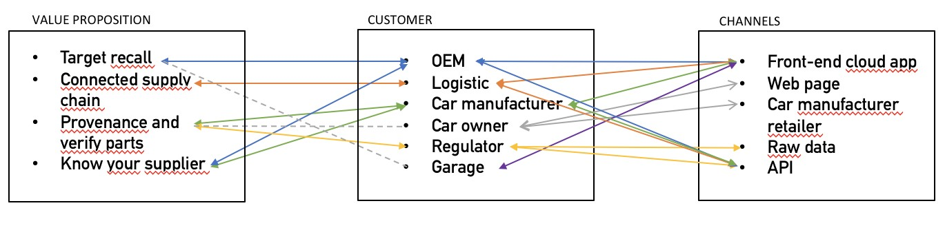

Figure 4.12. Customer perspective

Revenue stream will come out from selling the service. The price will be shaped according to the player and services provided to them. There is a fixed cost to join the network and to rig the hardware needed. Moreover there is a variable fee based on the service usage. Over time, there is the chance to drop the price in case the system does not show enough market adoption or enough benefits for the ecosystem. In this case, the prices can be changed even if the service is already in place. Basically the revenue stream is similar to a no profit organisation in which everybody contribute for their involvement and positive externalities and the profit of the company will be used to repay the systems creation and development. Actors who will not receive influent benefits will be not charged, and their expenses will be covered by the main actors as shown in figure 4.13 which link every actor with their revenue stream for the company.

Cost structure There is a huge initial investment to develop the software and put the service online. Once online there will be need of continuous maintenance and software development. The variable cost related to the usage and computational needs will be covered by variable fee (figure 4.13). The service usage by the actors will e easy to compute based on transactions and queries to the database. Another source of cost is related to staying connected to the community and making sure that the company satisfies the real customer’s needs.

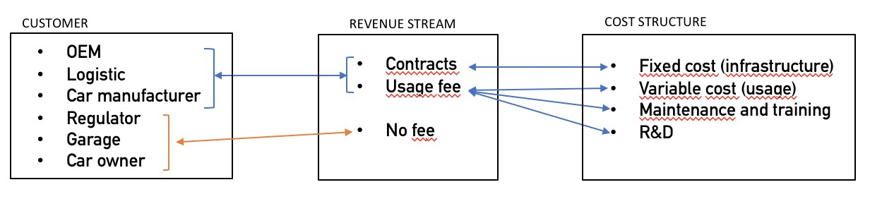

Figure 4.13. Financial perspective

Chapter 5

# Solution

Based on our analysis we are now going to define a blockchain based supply chain management solution. Our idea is to develop a first light version of cloud service with the main object of sharing in real time data from sensors along supply chain It’s important at this stage define all the details which will be developed in this section:

Goal: Our platform will be used by the main actors in the automotive supply chain (suppliers, logistics, car manufacturer, retailer, car owner, regulators), to improve the information sharing in a secure way, support existing business process and creating new ones. The structure will be of a Service as a Software (SaaS) with front-end application tailored for different actors and APIs to support internal development. There will be no manual data entry, all the datas will come out from the sensors along the supply chain.

Platform: There are more than 25 platforms on which you can build a blockchain app without beginning from scratch. For our business needs we choose to focus on the Hyperledger, the most promising platform for many different business application. It is already supported by big players in the market, and its open source environment boost the development. It is actually the most flexible and there are already many internet playground to code and test your own Hyperledger blockchain.

Consensus Mechanism: In the market there are already many different blockchain system, with different characteristics. The main difference is the consensum algorithm which is the main variable influencing speed, efficiency and vulnerability. We selected Practical Byzantine Fault Tolerance (PBFT) which is the most popular permissioned blockchain platform protocol and is currently used by Hyperledger Fabric. In industries like automotive, it may make more sense to rely on node votes. Because participants in a blockchain managing spare parts are more likely to be altruistic and operate under real identities than users of a highly anonymous, unregulated system like Bitcoin, the benefits of avoiding PoW may outweigh the risks associated with node voting as the solution to Byzantine faults.

UI/UX: Once all the backend things are decided, the next step is to create a UI and admin console. Here, you will decide the right front-end programming language, servers, and external databases for your app development process. For the early stage nature of the project, we will use online playground like IBM Bluemix, particularly good for Hyperledger Fabric development. The language required will be Go and Java for application running on blockchain.

Hardware: The hardware infrastructure will be rented from a cloud server provider (IBM/AWS). Moreover every item tracked will need IoT link to create a digital twin. Creating a digital twin is probably the most challenging objective. We choose RFID for the benefits in process speed with no need of pointing it, but other kind of sensors will be used based on business requirements (size, temperature..). To get datas from the part and put it on the blockchain RFID antennas will be needed.

Proof: Blockchain is still in its nascent stage, so it is better to go for MVP development approach. Shortly, it is recommended to create a workable solution with core features of the planned application and test it, rather than launching the complete solution. For this reason we will focus in creating valuable service for the main actors (suppliers, logistic, car manufacturer) neglecting by now the others (car owner, retailers, regulator).

## 5.1 Solution canvas

This is the representation of "TO-BE" solution (5.1). The service will add value manly to main actors (supplier/car manufacturer/logistic) and only in a second phase will address retailers and final users. The main outcome is the inbound efficiency with cost reduction in logistic process, and the product verification to limit grey market that will increase revenue for suppliers and car manufacturer. The main challenge will be related to digital twin with a great network of sensors needed along the whole supply chain. The scalability will be solved with a lite consensum algorithm and the adaptability and flexibility with the choose of Hyperledger Fabric. Join communities and create consortium will be fundamental to adapt the service to actors requirements.

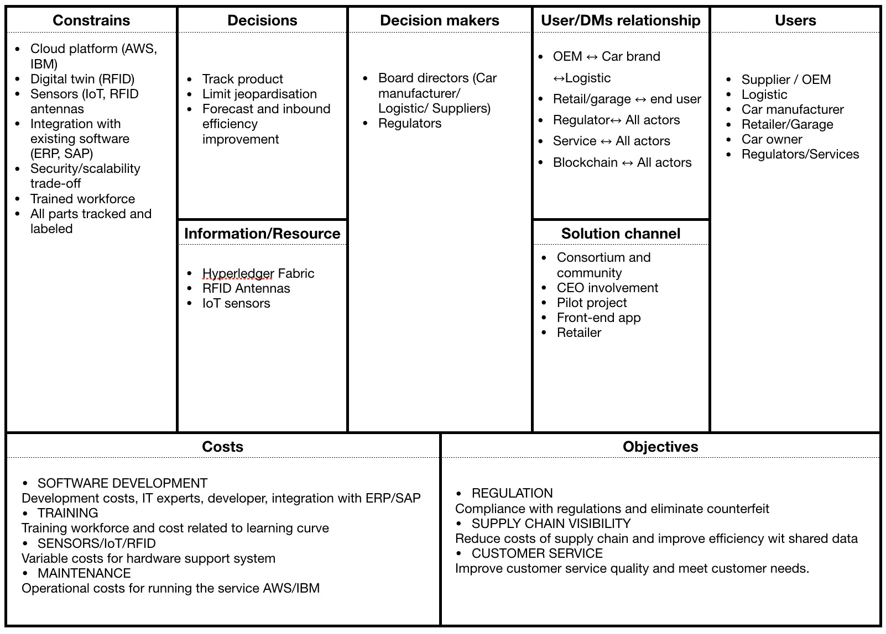

Figure 5.1. Solution Canvas ( SC )

## 5.2 Solution external analysis

Since now we have highlight the strengths of the solution proposed for all the actor, but our analysis still lack of considering external forces which will influence positively (opportunities) and negatively (Threats) our business model. In doing this an useful tools is the SWOT analysis. We will not recap the internal forces (Strengths and Weaknesses) as they match with the technology ones proposed in the blockchain section 2.5.

Table 5.1. Solution external analysis

|  |  |
| --- | --- |
| Opportunities | Threats |
| * Dealer and customer incentives * Extended vehicle ledger * Odometer fraud * Ride sharing and on-demand mobility services * Insurance contract * Auto leasing and finance * connected services * Electric vehicle payment | * Technological(new technology/new design) * customer behaviour * vertical integration trend * public policies * Adoption * exceeding control |

## 5.3 Costs

In this section we are going to evaluate the cost of the project. In doing this we divide the analysis in two section: software and hardware, and we assume a car manufacturer with the following characteristics:

* 5 percent market share worldwide
* 7M cars produced annually

Moreover logistics and OEMs production volume will be assumed to be fixed to one car manufacturer needs. With this assumption supplier will produce 7M car parts and all the parts will be managed by the same logistic provider. This assumption is needed because the differences in the market between the tre actors (car manufacturer, OEM and logistic) are not so defined and in many case, even if they could have different names, they are managed by the same company. In that case we assume that the logistic will be the inbound and outbound process of the company, the supplier the production warehouse and the car manufacturer the brand.

Software

Just like mobile application development cost, the cost to make a blockchain app differs depending on the app goals, features and efforts you put into the development process. Generally, once defined system requirements, SaaS development costs are highly predictable. In this case however Blockchain is still in a development phase and also the business requirements will comes out during the testing. We based our cost analysis on human resource who will be assigned to the project. We choose to allocate one software developer for every main actor. The average salary for a junior software developer in Italy is EUR 2.100 monthly. Moreover the team will be supported by 3 project managers, one for every main actor, considering that the car maker will be responsible of retailer and customer services (figure 5.2.

TEAM The team will be composed by:

* 5 Software developer (one for every main actor)
* 3 Project managers

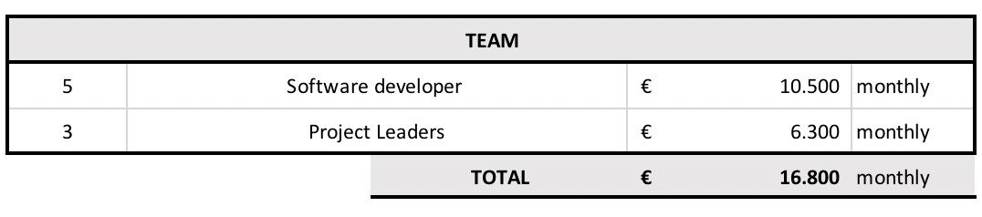

Figure 5.2. Team cost calculation

VARIABLE COSTS The blockchain cloud infrastructure will run on IBM. The costs of the service are available on internet. We need to estimate the number of transactions to compute the variable cost. We set the performance below:

* A car is composed by 500 parts on blockchain
* A single manufacturer produce 7M cars annually
* During the supply chain every part is processed 20 times

With these assumptions is easy to forecast transaction number. The performance obtained by Hyperledger Fabric deployed in a single cloud data center achieves an end-to-end throughput of more than 3.500 transactions per second with latency less than one second, which is enough to support peak of volume of 160% considering an estimation of 2200 transaction in a common scenario (figure 5.3).

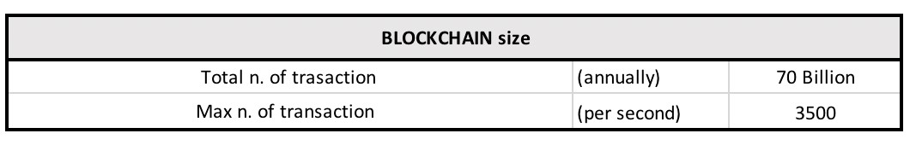

Figure 5.3. Network transactions estimation

The cost for using the IBM blockchain platform is 752 EUR/month plus 752 EUR/month for each small peer deployed (figure 5.4). We assumed five channel owner which are the main actors in the supply chain, and twenty transactions per item. It comes out that the cost of developing and run a blockchain supply chain service for an around 200 B EUR market may be around 450k EUR/year. Moreover as stated by IBM blog posting

[84].

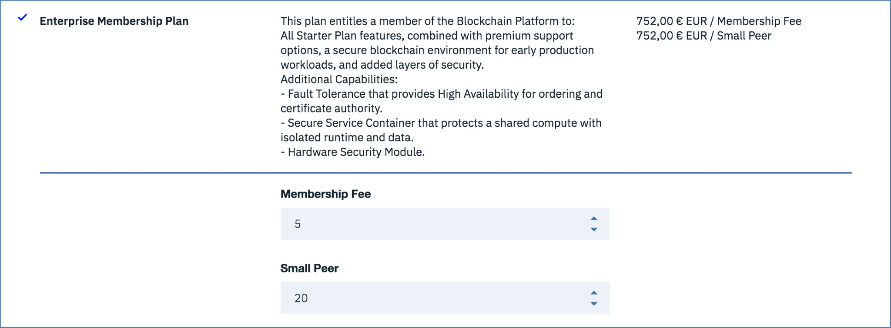

Figure 5.4. IBM Bluemix Blockchain platform cost

Hardware

In this section we will evaluate the RFID technology. Described in section 6.2.1, Radio Frequency Identification, it is not widely adopted. The main reasons are its cost and performance in selected environment. Neglecting this we will try to compute the cost of the adoption of this technology, considering that the digital twin may be created with a simple barcode. We assign an RFID sensor on every car part, general ones like screws and bolts will not be counted.

* A single RFID for every car part (0.10 EUR)
* RFID antennas and sensors (10k EUR) [83]

As shown in the figure 5.5, the adoption of RFID will require great investments.

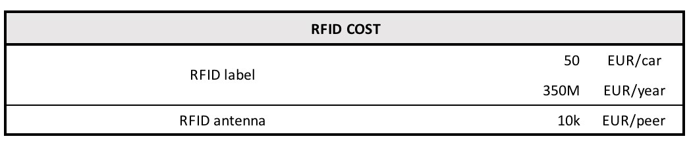

Figure 5.5. RFID adoption cost

considerations

The results put in evidence that the main cost will be related to RFID. This technology will have a variable cost of 0.10 EUR per parts, not considering the fixed costs needed to update all the peers, like ship and trains (figure 5.6). The cost for running the Blockchain instead will not require huge initial investment, as the infrastructure will be provided by a cloud platform (IBM), and the open source environment will maintain low prices.

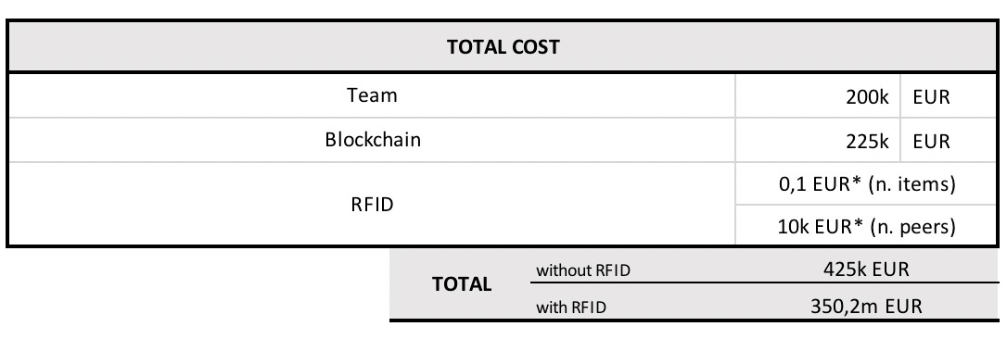

Figure 5.6. Total cost of blockchain service

## 5.4 Revenue

Advantages coming from the adoption of the service come from difference source. The main source will be supply chain visibility, and real time data sharing. We will not take into account a different workload for the increased data entry, but we assume it constant. Obviously, as already stated in many research, RFID has outstanding performance in supply chain, but it’s not widely adopted because needs huge investments. We will try to compute several benefits coming from RFID and traceability. We think that Blockchain will exploit its potential only with a solid IoT infrastructure, but it’s a process that will require much more time and investments respect the software development of blockchain.

Supplier/OEM

For a quantitative analysis of the benefits gained by suppliers and OEMs we focus on improved just-in-sequence operation of an automotive inbound logistics process. In order to analyze the economic effect of the RFID system developed in this study, the major benefits were determined through datas from interviews with the managers of production management departments [49]. Supply chain visibility will for sure reduce the cost of inventory, which we take into account in the logistic section. However the parts tracking should avoid the risk of production shutdown. An OEM has a cost of shutdown around 400 EUR/minute. We consider an average shutdown of 30 minutes in a conservative scenario of 5 times in one year [49]. This means that a tool to avoid sequencing and shortage errors will save 60k EUR (figure 5.7). This data doesn’t take in to account the savings in process provided by RFID technology, but it’s a benefit related only to traceability.

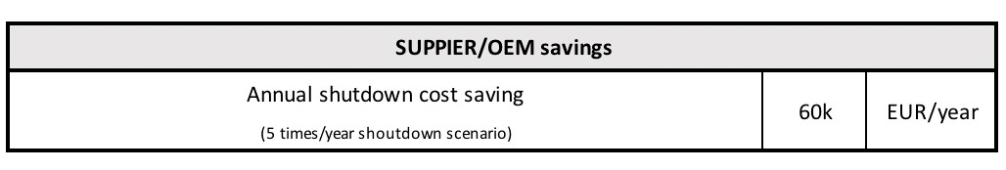

Figure 5.7. Supplier/OEM benefit from supply chain visibility

Logistic

In the logistic process, we have many benefits which fit a quantitative analysis. Firstly in the category of items in dispute, the automated tracking and enhanced visibility of RFID will benefit "lost and found" items category which represents 18 percent of the work performed by customer service representatives [65]. Mainly, the check fo parts reported missing be done upon request by logistic personnel. The labor cost for the personnel in charge of tracking and tracing amounts to 10.00 euro per hour. It is estimated that, on average, logistics representatives spend 52 man-hours per week tracking and tracing for these items alone [65]. This represents a direct labor cost of 30k per year.

Moreover, focusing on the warehouse, the time required for checking and allocate items at arrival could be reduced with the automatisation of RFID. It is expected that with an integrated RFID system the time spent on manual data entry and related errors would be eliminated. It’s estimated that this would save on average 50 seconds per pallet [65]. Four fundamental logistic processes are considered to evaluate the impact of RFID: receiving, inventory counting, picking, and shipping (figure 5.8) [64] (All these data comes from a simulation in a logistic hub in Turkey).

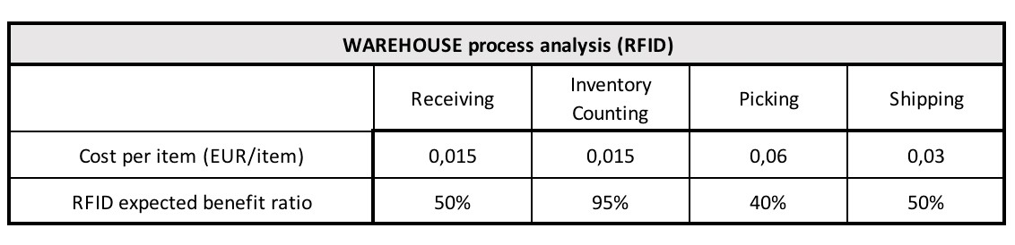

Figure 5.8. Warehouse process analysis with RFID adoption

Is important to notice that the considered savings count only one warehouse, is common that an item can undergo many tiers during the supply chain. Results are presented in figure 5.9.

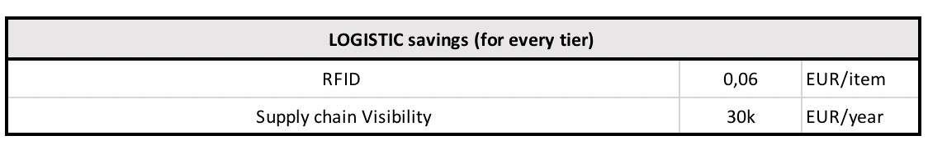

Figure 5.9. Logistic savings from RFID and supply chain visibility

Car manufacturer

Target recall will be one of the main benefit that will receive the car manufacturer, which as already explained in subsection 4.3.2 before can affect seriously revenues. The increased value of the brand and the many possible externalities of complete view of product lifecycle are not easy to compute quantitatively. For this reason we will take in consideration the counterfeited part market and the increased revenues coming from product certification.

* A product recall may cost on average 10B EUR [80].
* Worldwide automotive counterfeited parts markets account roughly EUR 40 billion

[75].

* We assume a 5 percent market share (Wolkswagen has 7,2 percent market share with EUR 2 billion revenues [89]).

Results are presented in figure 5.10. In this phase we consider a perfect factor of counterfeited product removal. Moreover the cost related to product recall is an opportunity cost in case of defective parts after the commercialisation which may affect revenues.

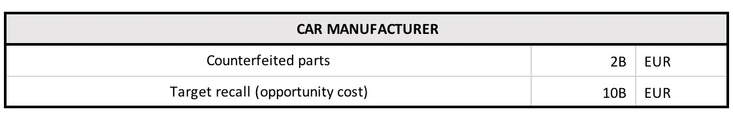

Figure 5.10. Car manufacturer benefits from product certification and supply chain visibility

Considerations

Benefits coming from Blockchain are hard to compute, but it’s easy to understand the importance for the market of objectives like visibility and tracking as stated in the value proposition section 4.5. The supply chain visibility, besides many positive externalities like decreasing costs and work hours will have positive impact in revenues fighting not authentic car parts which jeopardise the market. In figure 5.11 is presented the results of the visibility and RFID strategy. This value depends on supply chain complexity, in fact inbound and outbound process carried out in every tier will perform better.

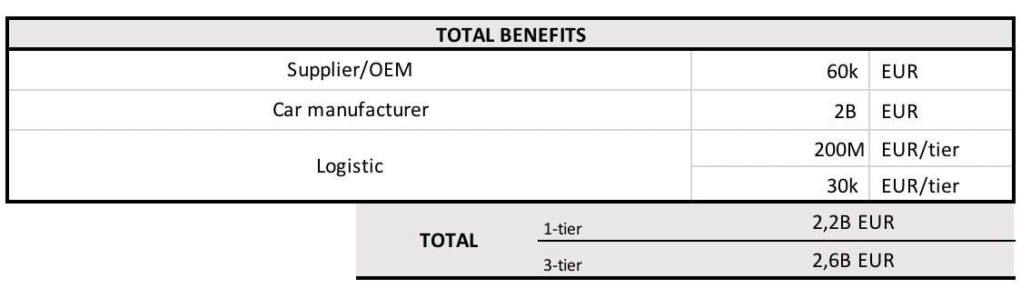

Figure 5.11. Total benefits from RFID, supply chain visibility and certification for every actor

## 5.5 Scenario evaluation

We are now going to evaluate costs and benefits for the whole process. We choose to develop two scenarios: one considering the application of Blockchain visibility ( figure 5.13) to the current supply chain, the other considering both blockchain and RFID ( figure 5.12). The automotive grey market is very large in volume and the blockchain could be the first effective plan to limit counterfeited part. In evaluating this we used a 25% factor, in other words car manufacturer will erode a quarter of counterfeited product market

The adoption of the RFID to tag items along the supply chain from one side will permit blockchain work properly without the human need and from another side will boost productivity in logistic process. In particular as already stated the tag price is around 0,10 EUR and with its adoption warehouse costs decrease of 0,06 EUR/tier. It’s clear that for simple supply chain with only one layer the benefits are not enough to justify the investment. However during the supply chain is common that car parts is moved through more than one storage. Considering a simple supply chain there are at least three tier: the supplier, the distributor and the retailer. The savings with the relatives assumptions will be of 0,18 EUR per item. Not considering the fixed costs for the RFID antennas the RFID will have a benefit of 0,08 EUR per item, a good result (figure 5.12).

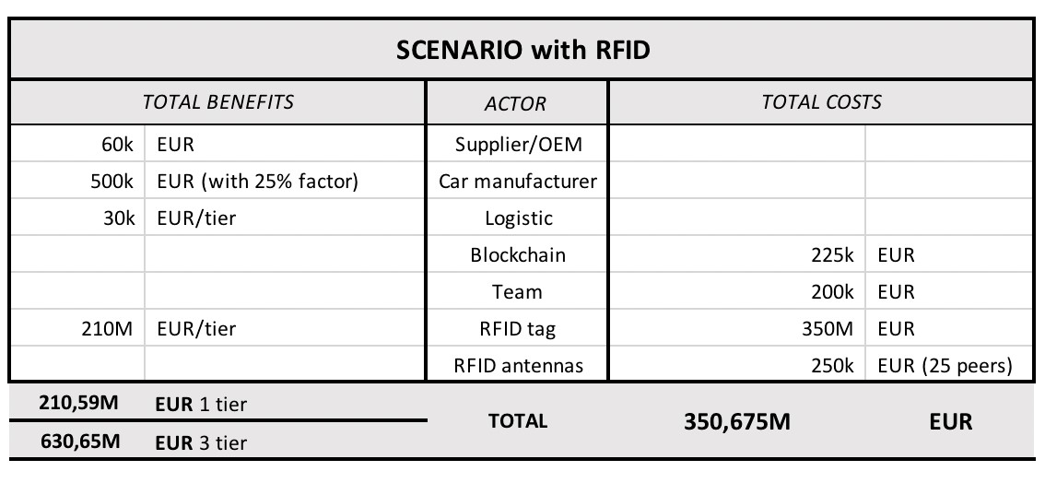

Figure 5.12. Scenario evaluation with RFID adoption

From the other side, not adopting the RFID will save an expensive investment, but the data collection will be not anymore automated, and this open to risky illicit actions and not considered states. However, even if the costs the item tracking will save around 60 k for the logistic process, the main benefit will be related to product certification ( figure 5.13). Another important consideration is about what the many actor involved in the automotive supply chain want to address in the near future. From the section 4.5 is clear that supply chain visibility is one and probably the most important objective and the possible externalities are hard to quantify numerically.

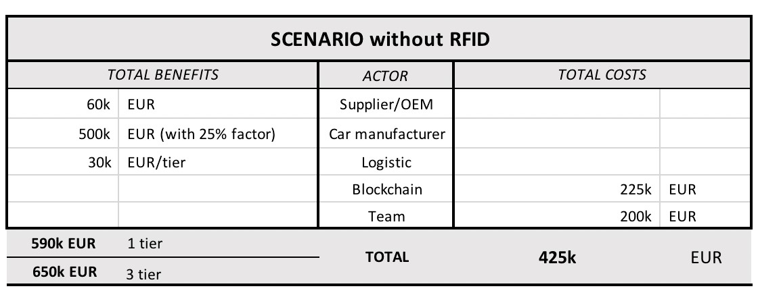

Figure 5.13. Scenario evaluation without RFID adoption

Chapter 6

# Technical Framework

In order to understand how the Blockchain technology will shape the supply chain and how we can provide the desired services (know your supplier, target recall, connected SC, Track and verified product) we propose a framework of a Blockchain-based supply chain quality management. This will be the base to the services proposed, but will fit also other service and different market supply chain. In making this is important to recap the concepts introduced in chapter 2, indeed the framework consists of smart contracts and various IoT sensors. BC provides safe distributed ledger with various quality information, assets information, logistics information and transaction information. Smart contracts bring privacy protection, intelligence and automation into this system, while IoT sensors get different kind of data from the real world [25].

## 6.1 Overview

The system architecture for supply chain quality management (SCQM) is composed by four layers (figure 6.1) which are described below:

IoT Sensor Layer. At the bottom we have IoT sensors layer, this is probably the most flexible layer and have to be adapted to the kind of supply chain, and based of its needs. A GPS is used to locate the product in the logistic process. An RFID technology could be used to record asset’s information and transaction information. Considering the high cost of RFID, alternatively a barcode could be used in some process where the accuracy is not strictly required and the data are not a lot [26]. In addiction we can use temperature, vibration and humidity sensors depending on circumstances. In our case the automotive parts are not affected by environmental state, for this reason we will likely need only RFID and GPS.

Data Layer. The second layers is Data layer, including blockchain and safe distributed ledger. There are four kind of data: quality data, logistic data, asset data and transaction data. Obviously the actors involved in the supply chain including supplier, manufacturer, logistic operator, retailer, regulators and financial institutes, as a node of the BC will keep a copy of data. With these data, smart contracts are used to execute quality control and improve efficiency of supply chain [25]. Is important to notice at this step, that not all these data have to be stored on BC. As we saw the costs of the infrastructure increase with the amount of data, and the immutability of the BC is not a requirement for all of them. Moreover we are considering a linear supply chain, but is possible that other private BC will be created in order to make the process of validation as lean as possible and avoid bottleneck. At this layer data integrability is fundamental to permit a smooth flow of information.

Contract Layer. The third layer is Contract layer. Only data sharing is not enough. Data gathering not only facilitate data sharing but also assist quality control and improve efficiency of the supply chain. The first concern about data sharing is privacy issues. Because competitive enterprises are operating on the same supply chain, someone could take advantage of confidential information. Therefore a digital identity is needed to control access authority to the data. Moreover with the real time data from IoT devices, smarts contract can be executed automatically, even commercial contracts can execute automatically and in real time. We think about the information flow in the supply chain which from customer demands flows until the supplier [27]. For example real time data from retailers, about costumer demands could be used to suggest purchasing and producing to manufacturers and suppliers. These kind of data is highly confidential for a retail business, but with the blockchain these data are secured.

Business Layer. At the top we have the Business layer. This includes various business activities in enterprises. Each enterprise in the supply chain is able to control and manage the product qualities with the support of BC and smart contracts. They can also make decisions on purchasing and manufacturing activities as described above, based on secured information provided by smart contracts [25].

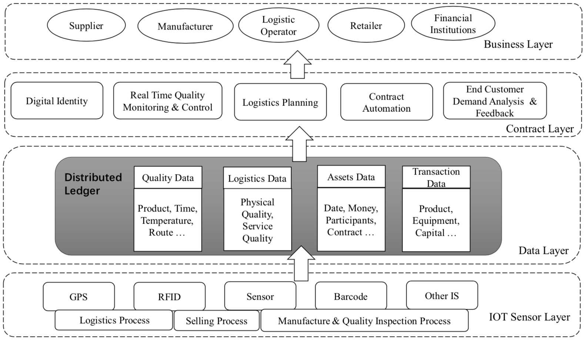

Figure 6.1. Blockchain framework

## 6.2 Digital twin

The first objective to address is the creation of a digital twin of physical parts. The model encompasses two dimensions explained in figure 6.2 took from the definition of supply chain in industry 4.0 by Hofmann [58]:

* Physical dimension: Autonomous and self controlled logistics sub systems like transport (e.g. via autonomous trucks), turnover handlings (e.g. via trailer unloading or piece picking robots) or order processing (e.g. via smart contracts on the blockchain technology) are interacting among each other.
* Digital dimension: Machine and sensor data are collected at level of the “physical thing” along the entire physical supply chain. Via a connectivity layer the gathered data is provided for any kind of analytics (e.g. in the cloud), possibly resulting in potential value-added business services.

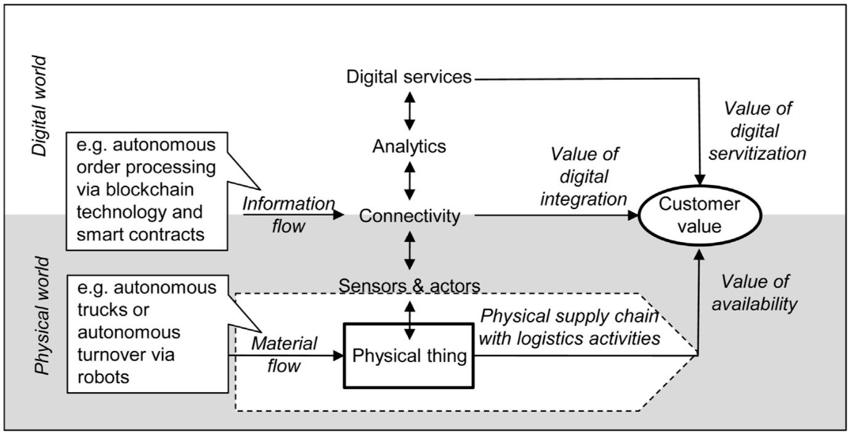

Figure 6.2. Logistic application model

### 6.2.1 RFID

Technical foundation

RFID is a technology for the automatic identification by radio of physical objects such as industrial containers, palettes, individual products and also people. The identification event takes place over transponders located in or on the respective objects, which can be addressed without physical contact, over the so-called "air interface", by the antenna on a scanner device [66]. Transponders are manufactured in various shapes and styles, operate in various frequency ranges and have either their own battery (active transponder) or are provided with energy from the electromagnetic field of the scanner (passive transponder). On the other hand, scanners are available on the market as both mobile devices with limited range and as devices for stationary installation, to which one or more external antennas can be connected to enable coverage of larger areas [52].

In contrast to the Barcode currently used for goods identification, RFID differentiates itself through the possibilities for bulk registration, identification without visual connection, unambiguous identification of each individual object, data storage on the object as well as great robustness towards environmental influences and destruction [53]. The mutuality of all transponder types lies in a unique ID number, which allows for identification no longer only of the product type but at the item level. Further characteristics cover, dependant on the manufacturer, also possibilities for data storage on the physical object, security mechanisms or sensors integrated into the tag, e.g. for recording temperatures or vibration.

Typical areas of application for RFID is Supply Chain Management, where the technology makes possible automatic stock control. Further application potential comes from the areas of product life-cycle management (e.g. with call-back actions, maintenance and service) and customer relationship management [54], even if the reliable functionality of RFID transponders is impaired in the presence of water and large amounts of metal [59].

Automotive applications

Various research and development studies on the RFID application in supply chain management have been reported. Literature demostarte that RFID applications can significantly improve the performance of distribution systems (by 33.8%) and stock availability (by 45.6%) [48].

In an automotive supply chain, due to the high tag price and the lack of infrastructure, RFID has been used in a ‘closed-loop’ manner [49] missing the wide perspective. Foster [70] suggested a system architecture for an automotive OEM and suppliers to monitor stillages in real-time bases by attaching active RFID tags on high valued stillages. Manik [51] pointed out the importance of Auto-ID technologies including RFID in order to solve data integrity problems caused by the manual entry of data in automotive supply-chain operations. In addition, they suggested a cost-benefit analysis model for RFID-system implementation to acquire real-time information of semi-manufactured goods and stock. Automotive supply chain consists of many participants. Because of that, for the purpose of operational cost saving, cycle time reduction, and efficiency enhancement, the close collaboration among the participants is a critical factor for success, and can be achieved by RFID-based real-time data exchange [49]. For these reason car manufacturer has been utilising RFID for in-house applications for a long time.

However, as stated by Ulrich, who is responsible for RFID strategy in DaimlerChrysler, automotive companies share the vision to use the technology beyond the core business processes in automation across the supply chain. However the major stumbling block to deploying this ideally throughout a company’s entire supply chain has been a "lack of agreement regarding which industry standards to use to provide a common understanding of processes, as well as a clear specification of data structures on RFID tags" [81].

Adoption in Italy

Based on the report of Statista we checked the adoption of RFID technology in automotive industry The statistic in figure 6.3 illustrates the share of wholesale and retail trade repair of motor vehicles and motorcycles companies using radio frequency identification devices (RFID) in Italy in 2017. In that year, 6.3% of wholesale and retail trade companies in automotive used radio frequency identification devices for product identification. The value is lower than in other manufacturing firms accept for person identification, due to the higher risk, and human factor involved in automotive product supply chain. The report put in evident as the RFID technology is mostly used to track product in business that require traceability and low integration with external actors like logistic (7.7%) and postal and currier activities (17.6%).

Possible reasons for the poor present diffusion of RFID applications seem to be the high failure and loss rate of the still rather expensive transponders, complex 1:n relationships, the need for a widespread infrastructure for most applications, and the lack of an appropriate and widely accepted global standard within the automotive industry [55].

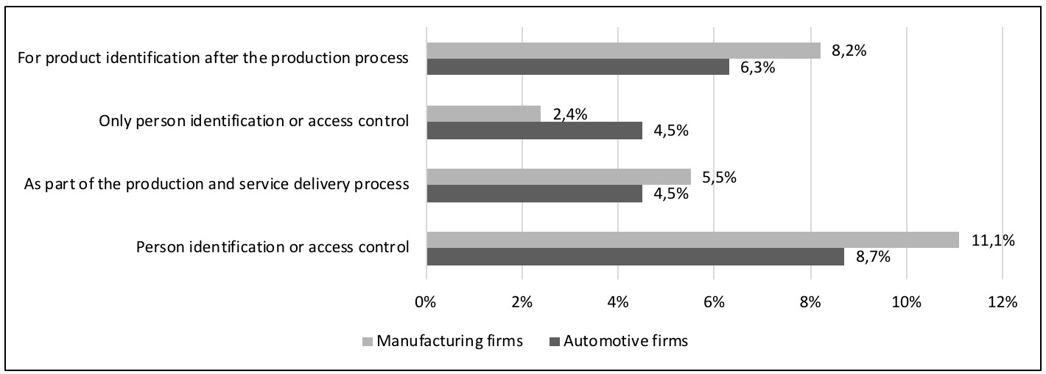

Figure 6.3. RFID adoption

## 6.3 Framework

Real-Time Quality Monitoring and Control Framework

The first framework which is analysed, is the one related to Real-time quality monitoring and control. As shown in figure 6.4, quality data in production process and inspection process would be uploaded and stored in the BC. Thanks to the real-time quality data, process and product quality are evaluated instantaneously with smart contracts and the results are sent back to suppliers, manufacturer and retailers. This solve a problem of the supply chain, particularly important in complex supply chain as the automotive one: the information flow. Car manufacturer spot product issue and communicate them directly to suppliers and logistic to mitigate the issue. Moreover the data of customer demand can be stored to the BC and help each actor to have a smooth workflow. The access to these data is controlled by digital identity and smart contracts. Many car manufacturer in fact, choose to be supported by different suppliers, to reduce risks, this creates ambiguity in the relations with them. Under the control of smart contracts and digital identity, each suppliers are not able to get access to the data from each other.

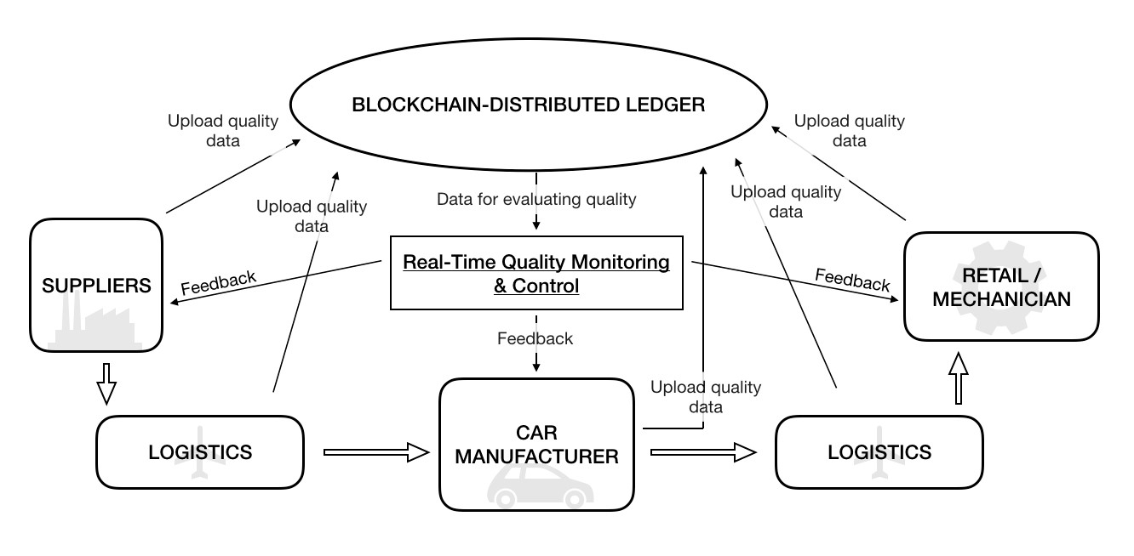

Figure 6.4. Real-Time Quality Monitoring and Control Framework

Contract automation Framework

An important application Blockchain based are smart contracts, and as we analyzed, sign and enforce them is a relevant cost. There are, for example, contracts between car manufacturers and suppliers. As shown in figure 6.5 contracts are deployed on both sides in partnership. The contracts will be executed automatically, and the execution results are sent to stakeholders on both sides when some unexpected errors happen. With the data on blockchain and smart contracts, all suppliers are able to get access to the analysis and feedback of customers on the products so they can decide how to make adjustment on their production. We think about innovative pricing strategies based on data at the end of supply chain from customers or retailer. This open another important consideration about supply chain finance. Financial gap appears when expenses and income in enterprises happen at different time. With the assets data, logistics data and transaction data, financial institutions would pay for enterprises on the supply chain with product mortgages. The pawns are protected by smart contracts according to their loan contracts. Under the control of digital identity, financial institutions are able to get access to the data of pawns that has been shared among suppliers, manufacturer, logistic operators and retailers, and regulator can monitor all the process to prevent illegal action.

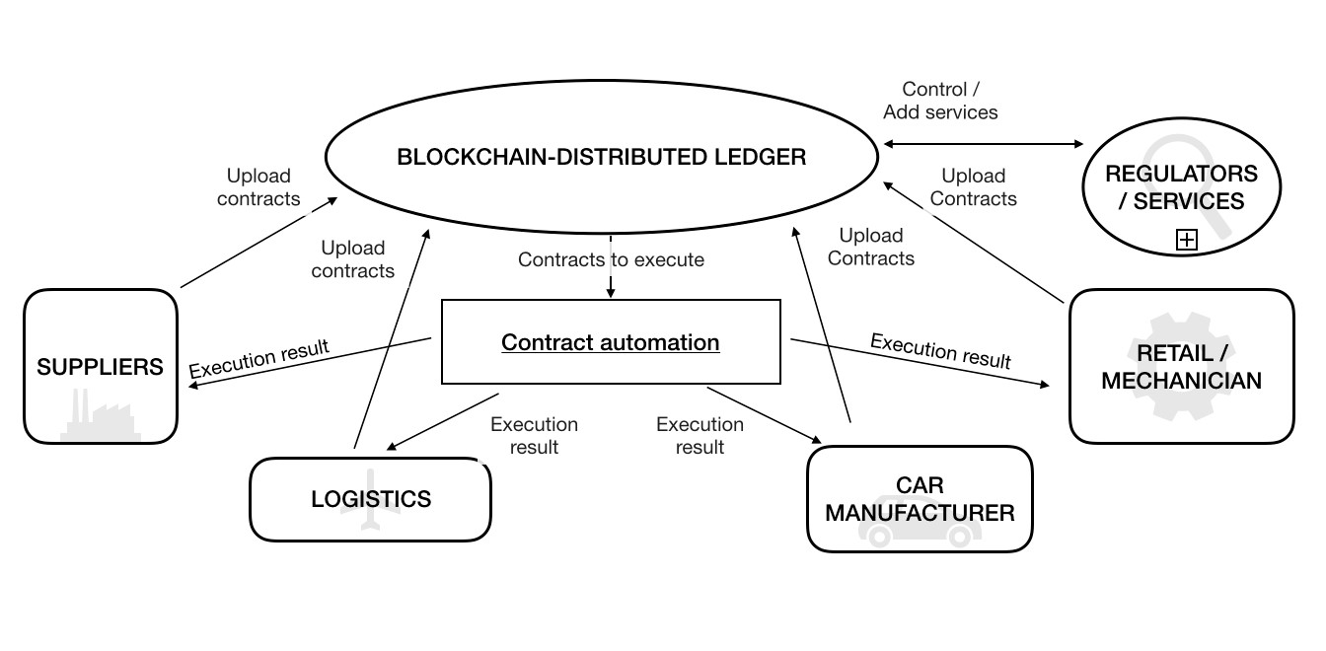

Figure 6.5. Contract automation

Logistic planning

The most important part in supply chain is probably logistic planning. The last few decades have seen the introduction of flexible manufacturing systems (FMS), of new approaches to inventory based on materials requirements planning (MRP) and just-in-time (JIT) methods and, perhaps most important of all, a sustained emphasis on total quality management (TQM). In this scheme of things, logistics is therefore essentially an integrative concept that seeks to develop a system-wide view of the firm. It is fundamentally a planning concept that seeks to create a framework through which the needs of the marketplace can be translated into a manufacturing strategy, which in turn links into a plan for procurement. In particular, in the automotive market, the logistic process have to deal with many stakeholders in a global scale [28]. As shown in figure 6.6 with the use of Blockchain, all these process are centralised in a decentralised infrastructure, avoiding issues of software integration. For example when the data from OEM and suppliers are uploaded in the BC, all the actors are notified, based on digital identity permissions. Even all the suppliers, which may act in the same competitive environment, have access to data based on their digital identity avoiding risky data flow but allow important synchronisation opportunity. In a synchronous supply chain the management of in-bound materials flow becomes a crucial issue. Thus, for example, rather than one supplier making a series of deliveries in small quantities to a customer, the orders from a number of suppliers are combined into a single delivery. Focusing on the outbound part of the supply chain, BC have the same advantage open new possibility of optimisation for components delivering and fault product recall.

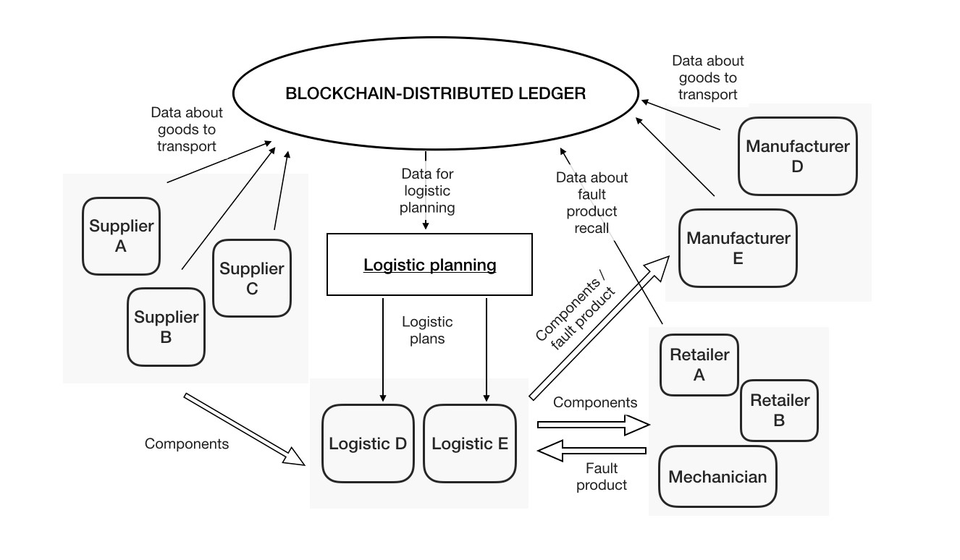

Figure 6.6. Logistic planning

Chapter 7

# Conclusion

The supply chain is still a land in which market leaders create their competitive advantage and in which the battle of cost reduction take place. Even if this is a very ambitious project, potential gains are unimaginable. During the dissertation we develop exhaustively many branch of the problem, but there are some points in which the technology and the studies have to go further. Blockchain is still in a development phase and there are still discussion about its scalability; in our opinion Hyperledger structure could solve this problem thanks to its flexibility and modular consensus algorithm. The main doubts are in its adoption, and market acceptance; by now it’s unlikely that all the supply chain actors will join the blockchain, even if this is a fundamental requirement to capture the added value of the technology.

The analysis underlined that even without exploring completely the blockchain potential, following the idea of MVP (Minimum Viable Product) to test and develop the technology in this environment, the solution results positively in financial terms, but clearly car manufacturer will be forced to address a market coverage for after-sale support to their customer. The main added value of blockchain stand alone will be product certification but the technology adoption will encourage to solve other business old problem, supply chain visibility is one of them. During the dissertation we discovered how much it counts for companies top management and for their business, however product traceability will be achieved with an increased cost for the need to track manually all the product lifecycle. In order to solve this problem, we proposed the automatisation of digital twin with the use of RFID.

Radio Frequency Identification is not a new technology and it seems really mature to face the great challenge of logistic, however in our opinion its performance are still not sufficient to perform well. By the way our idea is that, with the support of other technologies like artificial intelligence, RFID lack of reliability could be overcome, working on different layers of sensors to avoid critical data gathering. Another problem of IoT sensors is price, but as outlines in the dissertation, the financial gain will exceed costs.

Future analysis have to focus on the creation of an automated and reliable digital twin process, which will permit to gain the enormous flexibility of digital assets without be stuck in boring and inefficient data entering. This kind of system should support the product during the supply chain and also, with less automation required, during the whole lifecycle. The first step in automotive industry seems to be the vehicle digital identity which in our idea should be on blockchain. This will permit to have much more control on the product and customer by the car manufacturer and regulators. Obviously the challenge of connected car have to face the privacy issue, but as stated during the

*7 – Conclusion*

dissertation, blockchain and digital identities will be a stable foundation for many new innovative services for customers and business models.

# Bibliography

1. European Automobile Manufacturers Association, Automobile Industry Pocket Guide, 2012, p. 31
2. Alliance of Automobile Manufacturers, Driving The Economy Forward, April 2013, p. 3
3. Manufacturers Association, Inc., The Motor Industry of Japan, May 2013, p.1.
4. PWC, 2017 Automotive Industry Trends, 2017
5. McKinsey e Company, Inc., The road to 2020 and beyond: What’s driving the global automotive industry?, 2013
6. McKinsey e Company, Inc., Automotive revolution - perspective towards 2030, January 2016
7. McKinsey e Company, Inc., Savvy and sophisticated: Meet China’s evolving car buyers, September 2017
8. IHS Automotive, ‘Light Vehicles Sales Forecast’, October 2015
9. S. Nakamoto, “Bitcoin: A Peer-to-Peer Electronic Cash System,” 2008 [10] N. Szabo, Smart Contracts, 1994, p.1.
10. M. Swan, Blockchain - blueprint for new economy, 2015
11. D. Tapscott e A. Tapscott, Blockchain revolution, 2016
12. V. Buterin, Ethereum White Paper, 2015
13. Coy, P. and Kharif, O. This Is Your Company on Blockchain. Bloomberg. (2016)

[https://www*.*bloomberg*.*com/news/articles/2016-08-25/this-is-your-companyon-blockchain](https://www.bloomberg.com/news/articles/2016-08-25/this-is-your-company-on-blockchain)

1. F. Tian, An information System for Food Safety Monitoring in Supply Chains based on HACCP, Blockchain and Internet of Things, 2018 [http://epub*.*wu*.*ac*.*at/6090/](http://epub.wu.ac.at/6090/)
2. A. Dorri, S. Kanhere and R. Jurdak, Towards an Optimized BlockChain for IoT. 2017
3. K. Christidis, M. Devetsikiotis, Blockchains and Smart Contracts for the Internet of Things. 2016 IEEE 4, 2292-2303.
4. G. Zyskind, O. Nathan, Decentralizing Privacy: Using Blockchain to Protect Personal Data, 2015 DOI [10.1109/SPW.2015.27](http://dx.doi.org/10.1109/SPW.2015.27)
5. B. Blechschmidt, C. Stoke, How Blockchain Can Slash the Manufacturing “Trust Tax”, 2016
6. Crosby, Michael, "Blockchain Technology: Beyond Bitcoin." Applied Innovation (2016)
7. J.D. Bruce, Purely P2P crypto-currency with finite mini-blockchain. [http:// www*.*bitfreak*.*info/files/pp2p-ccmbc-rev1*.*pdf*,*(May2013)*.*](http://www.bitfreak.info/files/pp2p-ccmbc-rev1.pdf,%20(May%202013).)
8. T. McConaghy, BigchainDB: A scalable blockchain database. Bigchaindb- Whitepaper. 2016.
9. M. T. Ozsu, P. Valduriez, Principles of distributed database systems, 2011
10. A. Cockcroft, D. Sheahan, Benchmarking Cassandra Scalability on AWS - Over a million writes per second. 2011. [http://techblog*.*netflix*.*com/2011/11/benchmarking-](http://techblog.netflix.com/2011/11/benchmarking-%20cassandrascalability-on.html.)

[cassandrascalability-on*.*html*.*](http://techblog.netflix.com/2011/11/benchmarking-%20cassandrascalability-on.html.)

1. S. Chen, R. Shi, Z. Ren, Y. Shi, A Blockchain-Based Supply Chain Quality Management Framework, 2017 DOI [10.1109/ICEBE.2017.34](http://dx.doi.org/10.1109/ICEBE.2017.34)
2. F. Tian, "An agri-food supply chain traceability system for China based on RFID and blockchain technology." International Conference on Service Systems and Service Management IEEE, 2016, pp.1- 6.
3. R. B. Grant, Contemporary Strategy Analysis, 2015
4. M. Christopher, Logistics and Supply Chain Management, 2011
5. K. L. Croxton, S. J. Garcia-Dastugue, D. M. Lambert, and D. S. Rogers, “The supply chain management processes,” The International Journal of Logistics Management, vol. 12, no. 2, pp. 13–36, 2001.
6. A. Leon, Enterprise resource planning. McGraw-Hill Education, 2014
7. R. Sudarsan, S. J. Fenves, R. D. Sriram, and F. Wang, “A product information modeling framework for product lifecycle management,” Computer-aided design, vol. 37, no. 13, pp. 1399–1411, 2005.
8. M. Barratt and A. Oke, “Antecedents of supply chain visibility in retail supply chains: a resource-based theory perspective,” Journal of operations management, vol. 25, no. 6, pp. 1217–1233, 2007.
9. B. Edvardsson, M. Holmlund, and T. Strandvik, “Initiation of business relationships in service-dominant settings”, Industrial Marketing Management, 2008, Vol. 37, pp. 339–350.
10. IBM Institute for Business Value, “The Smarter Supply Chain of the Future: IBM Global Chief Supply Chain Officer Study.”, January 2009. [http://www*.*ibm*.*com/ supplychainstudy](http://www.ibm.com/supplychainstudy)
11. G. Perboli, GUEST
12. Osterwalder, The Osterwalder Business Model Ontology
13. Lindgardt, Z., Reeves, M., Stalk, G., and Deimler, M. S. (2009). Business Model Innovation: When the Game Gets Tough, Change the Game. Boston Consulting Group, (December), 9. DOI [/10.1108/10878570710833714](http://dx.doi.org//10.1108/10878570710833714)
14. R. Amit, C. Zott, Business Model Innovation: Creating Value In Times Of Change. Universia Business Review, (2009). DOI [https://doi.org/10.2139/ssrn.1701660](http://dx.doi.org/https://doi.org/10.2139/ssrn.1701660)
15. C. Zott, R. Amit, Business Model Design: An Activity System Perspective. 2009
16. A. Gambardella, A. M. McGahan, Business-Model Innovation: General Purpose Technologies and their Implications for Industry Structure. 2009
17. A. Gawer, M. A. Cusumano, Platform Leadership: How Intel, Microsoft, and Cisco Drive Industry Innovation (Harvard Business School Press, Boston). 2002
18. C. Shapiro, H. Varian, Information Rules: A Strategic Guide to the Network Economy (Harvard Business School Press, Boston). 1999
19. A. Smedlund, Value Cocreation in Service Platform Business Models. 2012
20. Deloitte, Accelerating technology disruption in the automotive market Blockchain in the automotive industry. 2018
21. H. T. Kamal, S. Tayyab, The Impact of Blockchain on Business Models. 2017
22. W. Mougayar, The Business Blockchain: Promise. Practice, and Application of the Next Internet Technology. 2016
23. Gallersdorfer, S. S. Ulrich. Analysis of Use Cases of Blockchain Technology in Legal Transactions. Munich : TUM Department of Informatics, 2017
24. I. Vlachos, A hierarchical model of the impact of RFID practices on retail supply chain performance. 2014 DOI [10.1016/j.eswa.2013.07.006](http://dx.doi.org/10.1016/j.eswa.2013.07.006)
25. Yong-Shin, K. Hyoennam , L. Yong-Han,Implementation of an RFID-Based

Sequencing-Error-Proofing System for Automotive Manufacturing Logistics. 2018

1. F. Thiesse, E. Fleisch, Adoption and Diffusion of RFID Technology in the Automotive Industry. 2007
2. D. Manik, L. Toth, P. Dobrossy, Analysis of RFID application through an automotive supplier’s production processes. In Proceedings of the International Symposium on Computational Intelligence and Intelligent Informatics (ISCIII 2007), March 2007
3. S. Garfinkel, H. Holtzman, Understanding RFID Technology. 2005
4. K. Finkenzeller, RFID-Handbook. Wiley, Chichester. 2003
5. G. Ferguson, Have Your Objects Call My Objects. Harvard Business Review, 80 (6) , 138–144. 2002
6. M. Strassner, E. Fleisch, Segment evaluation automotive – Applications of AutoID technology in the automotive industry. M-Lab Report No. 15, St.Gallen. 2002
7. M. Scherer, Performance and Scalability of Blockchain Networks and Smart Contracts, 2017
8. World Trade Organization (WTO),Trade finance and SMEs, 2006
9. E. Hofmann , M. Rosch, Industry 4,0 and the current status as well as future prospects, 2017
10. M. Brettel, N. Friederichsen, M. Keller, M. Rosenberg, How Virtualization, Decentralization and Network Building Change the Manufacturing Landscape: An Industry 4.0 Perspective, 2014
11. J. Horning - PwC, Automotive Supplier Survey 2017
12. E. Golan, B. Krissoff, F. Kuchler, L. Calvin, K. Nelson, G. Price, Traceability in the US food supply: economic theory and industry studies. Agricultural Economic Report, Iss. 830, No. 3, pp. 1-56. 2004
13. A. E. Saak, Traceability and reputation in supply chains. International Journal of Production economics, Vol. 177, pp. 149-162. 2016
14. M. M. Aung, Y. S. Chang, Traceability in a food supply chain: Safety and quality perspectives. Food Control, Vol. 39, pp. 172-184. 2014
15. A. Ustundag, M. Tanyas, The impacts of Radio Frequency Identification ( RFID ) technology on supply chain costs, 2008
16. S. Veronneau, J. Roy, RFID benefits, costs, and possibilities: The economical analysis of RFID deployment in a cruise corporation global service supply chain. 2009
17. P. Schmitt, F. Thiesse, E. Fleisch, Adoption and Diffusion of RFID Technology in the Automotive Industry. 2007
18. Roland Berger, Global Automotive Supplier Study. 2017
19. Capgemini Consulting, Third-Party Logistics Study. 2017
20. Accenture consulting company, Reach Out and Touch the Future: Accenture Connected Vehicle Services. 2014
21. P. Foster, A Case Study to Track High Value Stillages using RFID for an Automobile OEM and its Supply Chain in the Manufacturing Industry. 2006 DOI [10.1109/INDIN.2006.275717](http://dx.doi.org/10.1109/INDIN.2006.275717)
22. [https://strategyzer*.*com/](https://strategyzer.com/)
23. [https://medium*.*com/s/story/how-does-the-blockchain-work-98c8cd01d2ae](https://medium.com/s/story/how-does-the-blockchain-work-98c8cd01d2ae)
24. [https://www*.*mckinsey*.*com/business-functions/digital-mckinsey/ourinsights/using-blockchain-to-improve-data-management-in-the-publicsector](https://www.mckinsey.com/business-functions/digital-mckinsey/our-insights/using-blockchain-to-improve-data-management-in-the-public-sector)
25. [https://www*.*forbes*.*com/sites/samantharadocchia/2018/06/21/3-automotiveconsumer-safety-issues-blockchain-will-help-resolve/#2eea1a486387](https://www.forbes.com/sites/samantharadocchia/2018/06/21/3-automotive-consumer-safety-issues-blockchain-will-help-resolve/#2eea1a486387)
26. [https://automotivelogistics*.*media/intelligence/16979](https://automotivelogistics.media/intelligence/16979)
27. [https://en*.*wikipedia*.*org/wiki/Bitcoin](https://en.wikipedia.org/wiki/Bitcoin)
28. [http://www*.*tesa-scribos*.*com/eng/markets/automotive_industry/automotiveindustry-component-suppliers-spare-parts-counterfeit-protection-greymarket-protection-and-theft-prevention*,*7688028*,*1*.*html](http://www.tesa-scribos.com/eng/markets/automotive_industry/automotive-industry-component-suppliers-spare-parts-counterfeit-protection-grey-market-protection-and-theft-prevention,7688028,1.html)
29. [https://www*.*bordermail*.*com*.*au/story/4403428/huge-haul-of-fake-carparts-bound-for-australia-seized-in-middle-east/](https://www.bordermail.com.au/story/4403428/huge-haul-of-fake-car-parts-bound-for-australia-seized-in-middle-east/)
30. [https://www*.*forbes*.*com/sites/samantharadocchia/2018/06/21/3-automotiveconsumer-safety-issues-blockchain-will-help-resolve/#287c75d76387](https://www.forbes.com/sites/samantharadocchia/2018/06/21/3-automotive-consumer-safety-issues-blockchain-will-help-resolve/#287c75d76387)
31. [https://www*.*ft*.*com/content/e02969fc-0dc0-11e8-8eb7-42f857ea9f09](https://www.ft.com/content/e02969fc-0dc0-11e8-8eb7-42f857ea9f09)
32. [https://www*.*rfidjournal*.*com/articles/view?2815](https://www.rfidjournal.com/articles/view?2815)
33. [https://www*.*supplychain247*.*com/article/annual_maintenance_repair_and_ operations_mro_survey_2018_spending_on_the_ri/trends](https://www.supplychain247.com/article/annual_maintenance_repair_and_operations_mro_survey_2018_spending_on_the_ri/trends)
34. [https://www*.*atlasrfidstore*.*com/](https://www.atlasrfidstore.com/)
35. [https://www*.*ibm*.*com/blogs/research/2018/02/architecture-hyperledgerfabric/](https://www.ibm.com/blogs/research/2018/02/architecture-hyperledger-fabric/)
36. [https://www*.*edx*.*org/course/blockchain-for-business-an-introduction-tohyperledger-technologies](https://www.edx.org/course/blockchain-for-business-an-introduction-to-hyperledger-technologies)
37. [https://www*.*hyperledger*.*org/](https://www.hyperledger.org/)
38. [https://ieeexplore*.*ieee*.*org/Xplore/home*.*jsp](https://ieeexplore.ieee.org/Xplore/home.jsp)
39. [https://medium*.*com/@philippsandner/application-of-blockchaintechnology-in-the-manufacturing-industry-d03a8ed3ba5e](https://medium.com/@philippsandner/application-of-blockchain-technology-in-the-manufacturing-industry-d03a8ed3ba5e)
40. [https://statista*.*com](https://statista.com)